**GREENHOUSE MONITORING AND CONTROL USING IOT**

***A project report submitted to***

### JAWAHARLAL NEHRU TECHNOLOGICAL UNIVERSITY ANANTAPUR, ANANTAPURAMU

*in partial fulfillment of the requirements*

*for the award of degree of*

**BACHELOR OF TECHNOLOGY**

**in**

**ELECTRONICS AND COMMUNICATION ENGINEERING**

***Submitted by***

|  |  |
| --- | --- |
| **POOLA PRIYAVARSHINI** | **18121A04G9** |
| **MUMMINENI SRAVANI** | **18121A04D5** |
| **NAGA SAI DHANYA V** | **18121A04D8** |
| **RAVVA HEMANTH VENKATA GANESH** | **18121A04J2** |

***Under the Guidance of***

**Dr.M. DHARANI, MTech,** **Ph.D.,**

Associate Professor, Dept. of ECE



**Department Of Electronics and Communication Engineering**

SREE VIDYANIKETHAN ENGINEERING COLLEGE

**(AUTONOMOUS)**

Sree Sainath Nagar, A. Rangampet, Tirupathi - 517102.

**(2018-2022)**

SREE VIDYANIKETHAN ENGINEERING COLLEGE

(AUTONOMOUS)

SreeSainath Nagar, A.Rangampet - 517 102

**VISION**

To be one of the Nation’s premier Engineering Colleges by achieving the highest order of excellence in Teaching and Research.

**MISSION**

* To foster intellectual curiosity, pursuit and dissemination of knowledge.
* To explore students’ potential through academic freedom and integrity.
* To promote technical mastery and nurture skilled professionals to face competition in ever increasing complex world.

QUALITY POLICY

Sree Vidyanikethan Engineering College strives to establish a system of Quality Assurance to continuously address, monitor and evaluate the quality of education offered to students, thus promoting effective teaching processes for the benefit of students and making the College a Centre of Excellence for Engineering and Technological studies.

DEPARTMENT OF ELECTRONICS AND COMMUNICATION ENGINEERING

**Vision**

To be a center of excellence in Electronics and Communication Engineering through teaching and research producing high quality engineering professionals with values and ethics to meet local and global demands.

**Mission**

* The Department of Electronics and Communication Engineering is established with the cause of creating competent professionals to work in multicultural and multidisciplinary environments.
* Imparting knowledge through contemporary curriculum and striving for development of students with diverse background.
* Inspiring students and faculty members for innovative research through constant interaction with research organizations and industry to meet societal needs.
* Developing skills for enhancing employability of students through comprehensive training process.
* Imbibing ethics and values in students for effective engineering practice.

**B.Tech (Electronics and Communication Engineering)**

**Program Educational Objectives**

After few years of graduation, the graduates of B.Tech (ECE) will be:

|  |  |
| --- | --- |
| **PEO1.** | Enrolled or completed higher education in the core or allied areas of electronics and  communication engineering or management. |
| **PEO2.** | Successful entrepreneurial or technical career in the core or allied areas of electronics  and communication engineering. |
| **PEO3.** | Continued to learn and to adapt to the world of constantly evolving technologies in the  core or allied areas of electronics and communication engineering. |

**Program Outcomes**

On successful completion of the Program, the graduates of B.Tech. (ECE) Program will be able to:

|  |  |
| --- | --- |
| **PO1** | **Engineering knowledge**: Apply the knowledge of mathematics, science, engineering fundamentals, and an engineering specialization to the solution of complex engineering problems. |
| **PO2** | **Problem analysis**: Identify, formulate, research literature, and analyze complex engineering problems reaching substantiated conclusions using first principles of mathematics, natural sciences, and engineering sciences. |
| **PO3** | **Design/development of solutions**: Design solutions for complex engineering problems and design system components or processes that meet the specified needs with appropriate consideration for the public health and safety, and the cultural, societal, and environmental considerations. |
| **PO4** | **Conduct investigations of complex problems**: Use research-based knowledge and  research methods including design of experiments, analysis and interpretation of data, and synthesis of the information to provide valid conclusions. |
| **PO5** | **Modern tool usage**: Create, select, and apply appropriate techniques, resources, and  modern engineering and IT tools including prediction and modeling to complex engineering activities with an understanding of the limitations. |
| **PO6** | **The engineer and society**: Apply reasoning informed by the contextual knowledge to assess societal, health, safety, legal and cultural issues and the consequent responsibilities relevant to the professional engineering practice. |
| **PO7** | **Environment and sustainability**: Understand the impact of the professional engineering solutions in societal and environmental contexts, and demonstrate the knowledge of, and need for sustainable development. |
| **PO8** | **Ethics**: Apply ethical principles and commit to professional ethics and responsibilities and norms of the engineering practice. |
| **PO9** | **Individual and team work**: Function effectively as an individual, and as a member or leader in diverse teams, and in multidisciplinary settings. |
| **PO10** | **Communication**: Communicate effectively on complex engineering activities with the engineering community and with society at large, such as, being able to comprehend and  write effective reports and design documentation, make effective presentations, and give and receive clear instructions. |
| **PO11** | **Project management and finance**: Demonstrate knowledge and understanding of the  engineering and management principles and apply these to one’s own work, as a member and leader in a team, to manage projects and in multidisciplinary environments. |

**Program Specific Outcomes**

On successful completion of the Program, the graduates of B. Tech. (ECE) will be able to:

|  |  |
| --- | --- |
| **PSO1.** | Apply the knowledge of Electronics, Signal Processing, Communications, and VLSI & Embedded Systems to the solutions of real-world problems. |
| **PSO2.** | Analyze, Design and Develop solutions in real time in the domains of Electronics, Signal Processing, Communications, and VLSI & Embedded Systems. |
| **PSO3.** | Conduct investigations and address complex engineering problems in the domains of Electronics, Signal Processing, Communications, and VLSI & Embedded Systems. |
| **PSO4.** | Apply appropriate techniques, resources, and modern tools to complex engineering systems and processes in the domains of Electronics, Signal Processing,  Communications, and VLSI & Embedded Systems. |

Department of Electronics and Communication Engineering

**SREE VIDYANIKETHAN ENGINEERING COLLEGE**

**(AUTONOMOUS)**

Sree Sainath Nagar, A. Rangampet, Tirupathi - 517102.

Certificate

*This is to certify that the project report entitled* **“GREENHOUSE MONITORING AND CONTROL SYSTEM USING IOT”**

is the bona fide work done and submitted by

**POOLA PRIYAVARSHINI - (18121A04G9)**

**MUMMINENI SRAVANI - (18121A04D5)**

**NAGA SAI DHANYA.V - (18121A04D8)**

**RAVVA HEMANTH VENKATA GANESH - (18121A04J2)**

in the Department of Electronics and Communication Engineering, **Sree vidyanikethan Engineering College,** A.Rangampet, affiliated to **Jawaharlal Nehru Technological University Anantapur, Ananthapuramu** in partial fulfillment of the requirements for the award of the degree of **Bachelor of Technology** in **Electronics and Communication Engineering** during 2018-2022*.*

GUIDE HOD

**Dr. DHARANI, M.Tech., Ph.D.,   Dr. N. Gireesh, M.Tech., Ph.D.,** Associate Professor, Department of ECE                                           Professor & Head, Dept. of ECE.

INTERNAL EXAMINER EXTERNAL EXAMINER

**ACKNOWLEDGMENT**

We are deeply indebted to the supervisor **Dr.M. DHARANI, M.Tech., Ph.D** Associate Professor of Department of Electronics and Communication Engineering for her valuable guidance, constructive criticism and keen interest evinced throughout the course of our project work. We are really fortunate to associate ourselves with such an advising and helping guide in every possible way, at all stages, for the successful completion of this project work.

We express our deep sense of gratitude to **Dr. N. Gireesh, M.Tech., Ph.D.,** Professor and Head, Department of Electronic and Communication Engineering for his valuable guidance and constant encouragement given to us during this project and the course.

We express gratitude to our principal **Dr. B. M. Satish, M.E., Ph.D.,** for supporting us in completion of our project work successfully by providing the facilities. We are pleased to express our heart full thanks to our faculty in department of ECE of Sree Vidyanikethan Engineering College for their moral support and good wishes.

Finally, we have a notation to express our sincere thanks to friends and all those who guided, inspired and helped us in the completion of our project work.

**Project Members**

|  |  |
| --- | --- |
| **Poola Priyavarshini** | **-18121A04G9** |
| **Mummineni Sravani** | **-18121A04D5** |
| **Naga Sai Dhanya** | **-18121A04D8** |
| **R.Venkata sai Ganesh** | **-18121A04J2** |

**DECLARATION**

We hereby declare that project report entitled **“GREENHOUSE MONITORING AND CONTROL USING IOT”** being submitted by us for award of degree of Bachelor of Technology in Electronics and Communication Engineering, Jawaharlal Nehru Technological University Anantapur, Anantapuramu is a bona fide record of **“SREE VIDYANIKETHAN ENGINEERING COLLEGE”** and has not been submitted to any other courses or university for award of any degree.

**Project Members**

|  |  |
| --- | --- |
| **Poola Priyavarshini** | **-18121A04G9** |
| **Mummineni Sravani** | **-18121A04D5** |
| **Naga Sai Dhanya** | **-18121A04D8** |
| **R.Venkata sai Ganesh** | **-18121A04J2** |

**ABSTRACT**

Greenhouse effect is the process by which radiation from the planet’s atmosphere warms up its surface to a temperature above the atmospheric level. The thermal radiation from earth’s surface is reabsorbed by greenhouse gases and redirected in all directions. This, as a result, gives rise to a lot of negative consequences impacting the sustainability scenario of our planet earth. When carbon dioxide levels are high, the leaf pores shrink. Greenhouse, also called glasshouse, building designed for the protection of tender or out-of-season plants against excessive cold or heat. A green house is where plants such as flowers and vegetables are grown. Greenhouse’s warmup during the day when sun-rays penetrates through it, which heats the plant, soil and structure.

This project demonstrates the design and implementation of a various sensors for greenhouse environment monitoring and controlling with various techniques using Node MCU ESP8266 module. This greenhouse monitors and control system consists of temperature sensor, Air quality sensor, soil moisture sensor, LDR sensor, LCD display module, 12v DC fan, electric Bulb water pump motor, servo motor with IoT technology. The Temperature sensor, senses the level of temperature, if it goes high DC fan gets on and when the temperature goes low the fan gets off.Soil moisturesensor, senses the water level as the level decreases the pumps gets on. In the absence of light, the LDR sensor senses and the bulb starts glowing. Air quality sensorsenses the levels of carbon dioxide (CO2) present within the greenhouse and alerts the Arduino if the level of co2 decreases. By this way it will become easy to monitor and control the system. With the help of HTTP protocol, the Node MCU module is connected to the wireless internet connection or through IoT platforms like ubidots.com. The collected environmental parameters data sent to smartphones via online mode to the farmers to make the proper overlook on their fields, no matter how far they are just by using the IoT platform. In the field of agriculture and food production, the technology has paced up very quickly and is still furnishing its way, to optimize and achieve maximum plant growth in the field of agriculture. An accurate system would surely bring the change in this world of Android/IDS smartphone applications.

**Keywords**: Greenhouse, Temperature sensor, Soil moisture sensor, LDR sensor, Air Quality sensor, Arduino UNO, ESP266 Wi-fi module, Ubidots.com IoT platform

# **CONTENTS**

|  |  |  |
| --- | --- | --- |
| **CHAPTER NO.** | **TITLE** | **PAGE NO.** |
|  | **ACKNOWLEDGEMENT** | vi |
|  | **DECLARATION** | vii |
|  | **ABSTRACT** | viii |
|  | **LIST OF FIGURES** | xii |
|  | **LIST OF TABLES** | xiv |
| **CHAPTER 1** | **INTRODUCTION**   * 1. Background   1.2 Green House  1.2.1 Green House effect in Green House  1.2.2 Meaning of green House Technology  1.2.3 Need for Green House Technology  1.2.4 Types of Green house  1.2.5 Crops That Can be Grown in Green House  1.3 Effect Elements in Greenhouse  1.4 Embedded Systems  1.5 Overview of Embedded system architecture  1.6 Applications of Embedded systems  1.7 Combined Work | 1  2  2  3  4  4  4  5  7,8  12  16  16 |
| **CHAPTER 2** | **LITERATURE SURVEY** | 18 |
| **CHAPTER 3** | **IMPLEMENTATION**  3.1 Existing System  3.2 Proposed system  3.2.1 Objective of Proposed System  3.2.2 Block Diagram  3.3 Components used | 22  22  22  22  23  25 |
| **CHAPTER 4** | **HARDWARE TOOLS**  4.1 Arduino Microcontroller  4.2 Temperature and Humidity sensor  4.3 LDR sensor  4.4 soil moisture sensor  4.5 Rain sensor  4.6 Gas sensor  4.7 Wi-Fi(ESP8266)  4.8 Web server  4.9 Liquid crystal dispaly  4.10 Power Supply  4.11 Internet of Things | 26  26  31  32  34  35  36  36  41  42  46  51 |
| **CHAPTER 5** | **SOFTWARE IMPLEMENTATION**  5.1 Software requirements  5.2 About Arduino Compiler | 54  54  54 |
| **CHAPETR 6** | **PROJECT MANAGEMENT AND FINANCE FACTORS** | 61 |
| **CHAPTER 7** | 7.1 Experimental Results  7.2 Advantages  7.3 Applications  **CONCLUSION**  **ABSTRACT AND CONFERENCE CERTIFICATES**  **REFERENCES**  **BIO-DATA** | 63  68  68  69  70  75  78 |

# **LIST OF FIGURES**

|  |  |  |
| --- | --- | --- |
| **FIGURES** | **DESCRIPTION** | **PAGE NO.** |
| Figure 1.1 | Green House | 3 |
| Figure 1.2 | Greenhouse effect in greenhouse | 3 |
| Figure 1.3 | Overview of embedded systems | 13 |
| Figure 1.4 | Interfacing components in an embedded system | 15 |
| Figure 3.1 | Prosposed system architecture | 23 |
| Figure 4.1 | Arduino Board | 27 |
| Figure 4.2 | ATmega328-PU | 27 |
| Figure 4.3 | Pin description of Arduino | 28 |
| Figure 4.4 | Pin diagram of Arduino | 30 |
| Figure 4.5 | Temperature & Humidity Sensor | 31 |
| Figure 4.6 | LDR Sensor Module | 33 |
| **Figure 4.7** | Soil Moisture Sensor | **35** |
| **Figure 4.8** | Rain sensor module | **35** |
| Figure 4.9 | MQ4 Sensor | 36 |
| Figure 4.10 | Wi-Fi (ESP8266) module | 37 |
| Figure 4.11 | **Interfacing with Arduino** | 38 |
| Figure 4.12 | **Wi-Fi pin out** | 38 |
| Figure 4.13 | ESP8266 Internal circuit | 41 |
| Figure 4.14 | LCD pin diagram | 44 |
| Figure 4.15 | LCD connection | 46 |
| Figure 4.16 | Power supply | 47 |
| Figure 4.17 | Circuit diagram of LPC2148 | 47 |
| Figure 4.18 | Step-down transformer | 48 |
| Figure4.19 | Bridge Rectifier | 49 |
| Figure 4.20 | Voltage Regulator | 50 |
| Figure 4.21 | IOT | 51 |
| Figure 5.1 | Arduino Board and USB cable compiler | 55 |
| Figure 5.2 | Board Connector | 56 |
| Figure 5.3 | Opening Blink Example | 56 |
| Figure 5.4 | Source code written in arduin compiler | 57 |
| Figure 5.5 | Selecting an arduin uno | 57 |
| Figure 5.6 | Writing sketches | 58 |
| Figure 5.7 | Compilation under progress | 60 |
| Figure 7.1 | Greenhouse Monitoring and Control system | 63 |
| Figure 7.2 | Working of LDR sensor when sunlight is OK | 64 |
| Figure 7.3 | Working of LDR sensor when sunlight is low | 64 |
| Figure 7.4 | Temperature and Humidity Values and Working of DC fan Accordingly | 65 |
| Figure 7.5 | Soil moisture sensor and Values on LCD | 66 |
| Figure 7.6 | Rain sensor working when there is no rainfall | 67 |
| Figure 7.7 | Rain sensor working when there is rainfall | 67 |
| Figure 7.8 | Air Quality values from air quality sensor | 68 |

**LIST OF TABLES**

|  |  |  |
| --- | --- | --- |
| **TABLE NO.** | **DESCRIPTION** | **PAGE NO.** |
| Table 4.1 | Specifications of LDR sensor | 34 |
| Table 4.2 | ESP8266 Pin diagram | 39 |
| Table 4.3 | Pin function of LCD | 43 |
| Table 4.4 | 16*2 LCD commands | 46 |
| Table 6.1 | components and price | 61 |
| Table 6.2 | Time Management of project | 62 |

# 

# **CHAPTER-1**

**INTRODUCTION**

Food shortage is one of the greatest problems confronting mankind in the 21st century. Global warming and other weather elements have claimed substantial land mass that was available for crops cultivation. In order to address the problem, greenhouse practice which has been in existence for a very long time is now modernized and deployed in many parts of the world. This technology is yet to be embraced by many developing countries.

Developing plants has turned out to be innovative test in light of the fact that the field and strength of the plants are vital parameter now a day either for cash crops or food crops. One of the significant issues in the present agriculture is the less learning of the agriculture parameters, and less information about the developing innovations. In the past agribusiness structure, our people of old avoid the use of a specific development for specific plant growth, they rather used regular marvel for all plants.

There is continuous increase in demand for food production technology. Weather conditions are characterized by having predominantly long and hot summers and short and mild winters. Such climatic conditions put a great strain on the types of crops that could be successfully grown. This is very much true with most horticultural vegetables with medium thermal requirements (tomato, pepper, cucumber, watermelon, marrow, green bean, eggplant).

Agricultural means can satisfy the food production demand. But due to isotropic climatic conditions. This ultimately affects the plant growth. Also, there are many such problems associated with it. To overcome from this problem. Pests and diseases, and extremes of heat, humidity, light and temperature and irrigation is necessary to provide water.[11] The farmers have been using different irrigation technique for increasing production. These techniques were done by human intervention. But due to this sometimes either the plants consume more water or the water reaches late up to the plants.

The technological change in the agriculture can develop plants under uncommon normal natural conditions, also this develops specific plants under specific condition which in turn help to get more yield and less compost. Presently the advancement of precision agriculture in greenhouse, for plant development has turned out to be prominent on account of less cost innovations for the agriculturists to re arrive yield. Greenhouses protect crops from too much heat or cold, shield plants from dust storms and help to keep out pests. Light and temperature control allows greenhouses to become suitable place for growing plants. The cultivation exhibition of plants under controlled conditions. Greenhouses also are often used for growing flowers, vegetables and fruits.

Modern greenhouse technology deploys automation in agriculture which is now common place due to the low costs of electronic components required for its implementation. A lot of efforts have been made by many researchers to automate the traditional greenhouse system.

**1.1 BACKGROUND**

Today agriculture is changing in response to the requirements of modern society, where ensuring food supply through practices such as water conservation, reduction of agrochemicals and the required planted surface, which guarantees high quality crops are in demand. As it is well known that greenhouse is a building or complex in which plants are grown. These structures range in size from small sheds to industrialized buildings. Greenhouses are often used for growing flowers, vegetables and fruits. Greenhouses are very useful for they provide an optimal growing season, allowing you to sow plants earlier and harvest plants later and allows economic crops such as tomatoes, cucumbers, melons and aborigines to crop more successfully. Basic factors affecting plant growth such as sunlight, water Content in soil, air humidity, temperature, CO2 concentration. These physical factors are hard to control manually inside a greenhouse and there is a need for automated design arises.

**1.2 GREEN HOUSE**

Green house is a structural building which allow sun light to enter. It consists two parts.

* Structural building
* Covering Material (Glass, Plastic sheet, UV covering sheet)
* Structural building (Frame) can be of Aluminum or iron pipes, woods and the covering material can be of glass or plastic sheet.

Greenhouse is such kind of house which has mainly two parts. One part is its structural building frame and other one is its covering material. Structural building frame may be made of iron rode or wooden structure and covering material may be glass or plastic sheet.[16] For understanding greenhouse first of all we should have to know about what is greenhouse effect in greenhouse.

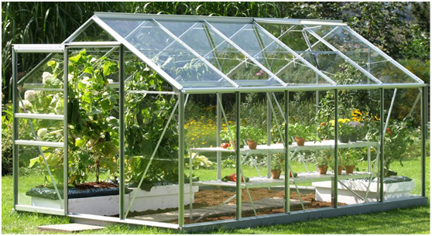

***Figure 3.2: Greenhouse***

**1.2.1 Greenhouse Effect in Greenhouse**

When the light coming from sun entered from the covering material that is transparent for sun light and come into the greenhouse then energy coming from the sun in form of rays absorbed by the plants, soil and structure and this energy is trapped into the greenhouse. Infrared rays are very useful for the growth of plants so by using the greenhouse these infrared rays trapped into the greenhouse. In this way overall energy inside the greenhouse increase and plant growth rate increase and plant growth are impressive.



***Figure 3.3: Greenhouse Effect in Greenhouse***

Due to this greenhouse effect the main advantages in greenhouse are followings

* Traps the Infrared rays from sunlight
* Increase the level of CO2
* Increase amount of chlorophyll

Plant health and growth impressive.

**1.2.2 MEANING OF GREEN HOUSE TECHNOLOGY**

Green house is a covered structural house it protects the plants form cold in winter, from heat in summer and from rain in monsoon. Greenhouse technology provides a controlled and favorable environment for the crops to grow and gives high yield in all seasons. This technology provides such opportunity that environment can be changed in it accordingly to the requirement of plant.

**1.2.3 NEED FOR GREENHOUSE TECHNOLOGY**

As we can see and observe that the rapid increase of world’s population day by day. Most Of the cultivable area is changing into industries due to industrial production demands. In this way the cultivable land is decreasing and the productivity of land become stable. This is the problem how to feed such huge population so we should have to use the greenhouse technology which gives more production per unit area.

**1.2.4 TYPES OF GREEN HOUSE**

There are many types of greenhouses depending upon types of its structural building formation and equipped systems.

* Low-cost green house
* Medium cost green house
* High-cost green house
* Only structure
* Equipped with cooling system, irrigation and fogging system
* Equipped with so many hitches system

**Advantages of Green House**

* Off-seasonal production.
* All kind of production in throughout the year.
* Higher yield per unit area.
* High value and quality production.
* Irrigation water and fertilizers wastage loss is reduced.
* Safety from pests and diseases is minimized.
* Good choice for tissue culture cultivation

**1.2.5 crops that can be grown in green house**

**Vegetable crops**

Mostly many kinds of vegetables can be growing in greenhouse house such as Brinjal, cauli flower, tomato, chillies, cabbage, okra, Palak etc.

**Nursery raising**

All vegetables and flowers can be grown in nursery

**Fruits**

All off-seasonal fruits can be grown

**Green House suitable for farmers**

Fully controlled greenhouse system is advanced forming system and this system is suitable for the farmers it will reduce the human labour and save the consumption of irrigation water and also save from the wastage of fertilizers under fully controlled environment production per unit area increased.

**Orientation of Green House**

The greenhouse should be oriented in such kind of direction where it receives ample amount of sun light throughout the day as well as throughout the year.

**Research Accomplishments**

Encouraging results have been obtained for the following crops at agriculture sector.

a. Tomato (in low and medium cost green house)

b. Palak (in both green house)

c. Tandeliyabhajee (in both green house)

d. Vegetable nursery raising (in both green house)

e. Rose (gladiator) cultivation (in medium cost only)

Further works are going on and also on other crops many of them are giving encouraging performances. Rooted crops like carrot, radish, etc. are not giving good results in green house.

**Problems in Green House Cultivation**

The main problems encountered are:

a. Fruit setting or pollination problem

b. Proper control of environment inside the green house

c. Problem of plant protection

Remedy to all the three problems is control of inside environment of greenhouse i.e. temperature, humidity, irrigation water application.

**Take precautions for the following**

1. Apply correct amount of irrigation water
2. Avoid from the pouring extra water
3. Maintaining proper humidity. Neither High nor low humidity this enhances pollination problem
4. Maintaining proper temperature. Higher temperature inside the system is the reason for dropping of flowers and in this way yield reduce.
5. Selection of such kind of crops which have some disease resistant
6. When you see that some disease attack to plant this take proper steps immediately for plant protection
7. Best way is that rather than one door uses double door system in the greenhouse
8. Do not enter into the greenhouse without any work.

**Reasons for Green House yielding more:**

1. U.V. film does not allow harmful U.V. rays to enter the greenhouse thus protecting the crop.
2. Inside environment remains under control.
3. Carbon dioxide released by the plants during the night is consumed by the plants itself in the morning. Thus, the plants get about 8-10 times more food than the open field condition.
4. Inside temperature is raised because of greenhouse effect.

**Tips for More Income from Green House**

1. Always plan for off-season crops.
2. Plan your crop in such a way that your produce should reach the market when there is maximum demand for it.
3. After the first harvest, take the rate on or plant next crop without wasting time
4. Reduce plant and row spacing inside the green house and get more yield.
5. Always fully utilize the green house space. Do not keep blank space.
6. Take immediate measures for plant protection whenever problem is traced. It spreads in a short time otherwise.
7. apply organic manures also in addition to the chemical fertilizers in order to maintain fertility
8. Solarize the land inside after about six months for about a week in order to make the land free from pests, germs, etc.
9. Follow a proper crop rotation. Avoid mono cropping for long.
10. Take a short-term training for green house cultivation before going for commercial crops in green house.

**1.3 EFFECT ELEMENTS IN GREENHOUSE**

One of the benefits of growing crops in a greenhouse is the ability to control all effective elements of the production that important to be monitored because it is directly related to the growth and development of plants.

**Temperature effects**

Different crop species have different optimum growing temperatures and these optimum temperatures can be different for the root and the shoot environment and for the different growth stages during the life of the crop. Since we are usually interested in rapid crop growth and development, we need to provide these optimum temperatures throughout the entire cropping cycle. If a greenhouse were like a residential or commercial building, controlling the temperature would be much easier since these buildings are insulated so that the impact of outside conditions is significantly reduced.

**Humidity effects**

Water vapor inside the greenhouse is one of the most significant variables affecting the crop growth. Humidity is important to plants because it partly controls the moisture loss from the plant. The leaves of plants have tiny pores, CO2 enters the plants through these pores, and oxygen and water leave through them. Transpiration rates decrease proportionally to the amount of humidity in the air. This is because water diffuses from areas of higher concentration to areas of lower concentration. Due to this phenomenon, plants growing in a dry room will most likely lose its moisture overtime. The damage can be even more severs when the difference in humidity is large.

The humidity control is complex because if temperature changes then relative humidity changes inversely. Temperature and humidity are controlled by the same actuators. The main priority is for temperature control because it is the primary factor in the crop growth. Based on the inside relative humidity value the temperature set-point can be adjusted to control the humidity within a determined range. Hence to control the required humidity is very complex task. For proper control of humidity internal air can be exchange with outside air by properly controlling ventilations of the greenhouse.

**Light Effects**

All things need energy to grow, human and animals get energy from food. Plants, on the other hand, get energy from the sun light through a process called photosynthesis. This is how light affects the growth of a plant. Without light, a plant would not be able to produce the energy it needs to grow. Aside from its effect through photosynthesis, light influences the growth of individual organs or of the entire plant in less direct ways. The most striking effect can be seen between a plant grown in normal light and the same kind of plant grown in total darkness. The plant grown in the dark will have a tall and spindling stem, small leaves, and both leaves and stem, lacking chlorophyll, are pale yellow. Plants grown in shade instead of darkness show a different response. Moderate shading tends to reduce transpiration more than it does photosynthesis. Hence, shaded plants may be taller and have larger leaves because the water supply within the growing tissues is better. With heavier shading, photosynthesis is reduced to an ever-greater degree and, weak plants result.

**Water level in soil effects**

Soil water also affects the crop growth. Therefore, the monitor & control of soil condition has a specific interest, because good condition of a soil may produce the proper yield. The proper irrigations and fertilizations of the crops are varying as per the type, age, phase and climate. The pH value, moisture contains, electric conductivity and the temp of a soil are some key parameters. The pH values and other parameters will help to monitor the soil condition. The temperature and the moisture can be controlled by the irrigation techniques like drift and sprinkles system in a greenhouse. The temperature of the soil and the inside temperature of the greenhouse are interrelated parameters, which can be, control by proper setting of ventilation. Since the temperature control is depends on direct sun radiation and the screen material used, the proper set point can adjust to control soil temperature. The temperature set-point value depends on actual temperature of the inside and outside of the greenhouse.

**1.4 EMBEDDED SYSTEMS**

An Embedded System can be portrayed as dealing with contraption that makes a particular centered showing up concerning. Gadgets, for example, the ventilation system, VCD player, DVD player, printer, fax machine, cell phone and whatnot are occurrences of installed structures. Each of these machines will have a processor and remarkable equipment to meet the particular fundamental of the application near to the installed programming that is executed by the processor for meeting that particular need. The presented composing PC programs are in like way called "firm thing". The desktop/flexible workstation phone a widely profitable PC.

Embedded Systems do a particular errand; they can't be acclimated to do grouped things. Preoccupations, word managing, bookkeeping, programming movement et cetera. In contains Embedded systems have unfathomably kept assets, especially You can utilize it for an assortment of vocations, for example, playing structures need to strife with two or three due dates. A particular occupation must be done inside a particular time. In some installed systems, called relentless structures, the due dates are stringent. Missing a due date may understand a calamity death toll or harm to property. Implanted frameworks are obliged for control. A comparative number of introduced systems work through a battery, the power utilize must be astoundingly low. Some implanted frameworks need to work in outstanding organic conditions, for example, high temperatures and Humidity.

**Application areas**

Around 99 for each penny of the processors made breeze up in presented frameworks. The presented framework publicize is a champion among the most amazing progression zones as these structures are utilized as a bit of particularly grandstand parcel purchaser hardware, office mechanization, current computerization, biomedical building, remote correspondence, information correspondence, media trades, transportation, military et cetera.

**Consumer appliances**

At home we utilize distinctive installed structures which intertwine computerized camera, impelled journal, DVD player, electronic toys, microwave stove, remote controls for TV and air course and cooling system, VCO player, PC redirection bolsters, video recorders and so forth. The present front line auto has around 20 installed structures for transmission control, motor start control, ventilating, course and whatnot. Most likely, even wristwatches are straightforwardly persuading the chance to be especially presented structures. The palmtops are capable installed structures utilizing which we can do various broadly important attempts, for example, playing beguilements and word preparing.

**Office automation**

The workplace mechanization items utilizing em installed frameworks are duplicating machine, fax machine, key phone, modem, printer, scanner and so on.

**Industrial automation**

Today a noteworthy measure of associations utilizes presented frameworks for process control. These merge pharmaceutical, bond, sugar, oil examination, atomic importance, control period and transmission. The implanted frameworks for mechanical utilize are intended to complete particular attempts, for example, viewing the temperature, weight, wetness, voltage, current and so on., and a while later make genuine move in context of the checked levels to control unmistakable gadgets or to send data to a solidified watching station. In hazardous current condition, where human closeness must be kept away from, robots are utilized, which are modified to do particular occupations. The robots are at the present time winding up being convincing and complete various beguiling and perplexed assignments, for example, outfit get together.

**Medical electronics**

In every practical sense every helpful apparatus in the pro's office is an installed structure. These arrangements join symptomatic assistants, for example, ECG, EEG, circulatory strain measuring contraptions, X-column scanners; prepare utilized as a bit of blood examination, radiation, colonoscopy, and endoscopy and so on. Changes in remedial contraptions have cleared path for more correct examination of torments.

**Computer networking**

PC sorting out things, for instance, ranges, switches, Integrated Services Digital Networks (ISDN), Asynchronous Transfer Mode (ATM), X.25 and diagram hand-off switches are embedded structures which execute the basic data correspondence traditions. For example, a switch interconnects two frameworks. The two frameworks may run assorted tradition stacks. The change's ability is to get the data packages from moving toward pores, look at the groups and send them towards the objective ensuing to doing principal tradition change. Most frameworks organization sorts of apparatus, other than the end structures (desktop PCs) we use to get to the frameworks, are embedded frameworks.

**Telecommunications**

In the field of communicate interchanges, the embedded structures can be organized as endorser terminals and framework outfit. The endorser terminals, for instance, key telephones, ISDN phones, terminal connectors, web cameras are embedded structures. The framework adapts fuses multiplexers, distinctive get to systems, Packet Assemblers Dissemblers (PADs), sate11ite modems et cetera. IP phone, IP entryway, IP protect et cetera are the latest introduced systems that give insignificant exertion voice correspondence over the Internet.

**Wireless technologies**

Moves in adaptable correspondences are clearing course for m way for some entrancing applications using embedded structures. The phone is one of the miracles of the latest decade of the 20'h century. It is a powerful introduced structure that gives voice correspondence while we are advancing. The Personal Digital Assistants and the palmtops would now be able to be used to get the opportunity to sight and sound organizations over the Internet. Compact correspondence structure, for instance, base station controllers, adaptable trading centers are moreover exceptional Embedded Systems.

**Security**

Security of people and data has dependably been a noteworthy issue. We have to secure our homes and workplaces; and furthermore, the data we transmit and store. Creating inserted frameworks for security applications is a standout amongst the most lucrative organizations these days. Security gadgets at homes, workplaces, airplane terminals and so on for confirmation and check are installed frameworks. Encryption gadgets are about 99 for each penny of the processors that are made wind up in inserted frameworks. Installed frameworks discover applications in. each mechanical section purchaser hardware, transportation, flight, biomedical building, fabricating, process control and modern robotization, information correspondence, media transmission, barrier, security and so forth. Used to encode the information/voice being transmitted on correspondence connections, for example, phone lines. Biometric frameworks utilizing unique finger impression and face acknowledgment are currently being broadly utilized for client validation in saving money applications and additionally for get to control in high security structures.

**Finance**

Budgetary overseeing through cash and checks are right now slowly clearing course for trades using splendid cards and ATM (Automatic Teller Machine, in like manner reached out as Any Time Money) machines. Astute card, of the measure of a Visa, has a little littler scale controller and memory; and it interfaces with the insightful card peruse ATM machine and goes about as an electronic wallet. Quick card advancement has the limit of presenting a cashless society. It is no deception to express that eyes wherever you go, you can see, or if nothing else feel, crafted by an embedded System.

**1.5 OVERVIEW OF EMBEDDED SYSTEM ARCHITECTURE**

Every embedded system consists of custom-built hardware built around a Central Processing Unit (CPU). This hardware also contains memory chips onto which the software is loaded. The software residing on the memory chip is also called the firmware. The embedded system architecture can be represented as a layered architecture as shown in Figure 1.1.



***Figure 1.1: Over view Diagram of embedded system***

The working system keeps running over the equipment, and the application programming keeps running over the working framework. A similar design is material to any PC including a desktop PC. Be that as it may, there are huge contrasts. It is not necessary to have a working framework in each installed framework. For little machines, for example, remote control units, aeration and cooling systems, toys and so forth. There is no requirement for a working framework and you can compose just the product particular to that application.[1] For applications including complex handling, it is fitting to have a working framework. In such a case, you have to incorporate the application programming with the working System and after that exchange the whole programming on to the memory chip.

The progression of a transportation structure has been the generative power for individuals to have the most essential human headway above creatures in the earth. Auto has a great noteworthiness in our step-by-step life. In the current circumstance, owning distinctive vehicles is seen as a financial prosperity in the overall population and accordingly the number of vehicles in the city has extended greatly in the earlier decade. On one hand, this may be seen as an adjustment in the lifestyles of people, along these lines, it can't be denied that there is a stark augmentation of road disasters, air defilement caused by the vehicles and wrongdoings related to the vehicles like theft et cetera.

We utilize it to go to our work place, remain in contact with our friends and family, and pass on our stock. Regardless, it can moreover pass on disaster to us and even can kill us through accidents. Speed is a champion among the most key and basic peril factors in driving. It impacts the reality of a crash, and also fabricates peril of being required in a crash. Regardless of various attempts taken by different authoritative and non-managerial affiliations all around the world by various ventures to careful against impulsive driving, yet disasters are happening every once in a while. In any case, many lives could have been saved if the emergency organization could get the crash information in time. Everything considered, capable customized incident acknowledgment with a modified cautioning to the emergency advantage with the setback zone is a prime need to save the profitable human life.

It uses it to go to our work put, stay in contact with our loved ones, and pass on our stock. Notwithstanding, it can additionally pass on catastrophe to us and even can execute us through mishaps. Speed is a boss among the most key and essential risk factors in driving. It impacts the truth of an accident, and furthermore manufactures risk of being required in an accident. Despite different endeavors taken by various definitive and non-administrative affiliations all around the globe by different dares to watchful against incautious driving, yet fiascos are occurring from time to time. Regardless, numerous lives could have been spared if the crisis association could get the accident data in time. Everything considered, proficient tweaked occurrence affirmation with an altered advised to the crisis advantage with the mishap zone is a prime need to spare the beneficial human life.

Every embedded system consists of custom-built hardware around a central processing unit (CPU). This hardware also contains memory chips onto which the software is loaded. The software residing on the memory chip is also called the firm ware. The operating system runs above the hardware, and the application software runs above the operating system as shown in figure. The same architecture is applicable to any computer including a desktop computer. However, there are significant differences.[2] It is not compulsory to have an operating system in every embedded system. For small appliances such as remote-control units, air conditioners, toys etc., there is no need for an operating system and you can write only the software specific to that application. For applications involving complex processing, it is advisable to have an operating system. In such a case, you need to integrate the application software with the operating system and then transfer the entire software on to the memory chip.



***Figure 1.3: Interfacing components in an embedded system***

As shown in above figure 1.3, the building blocks of an embedded system are:

* Central Processing Unit (CPU)
* Memory (RAM and ROM)
* Input devices
* Output devices

**Central Processing Unit**

The Central Processing Unit may be a microcontroller, microprocessor or a Digital Signal Processor. A microcontroller is a low-cost processor. On the microcontroller chip itself, there will be many other components such as memory, serial communication interface, A/D converter etc. [2] So, for small applications, a microcontroller is the best choice as the number of external components required will be very less. On the other hand, microprocessors are more powerful, but many external components are needed for them. Digital Signal Processors are mainly used for applications in which signal processing is involved such as audio and video processing.

**Memory**

The memory is categorized as Random-Access Memory (RAM) and Read Only Memory (ROM). The contents of the RAM will be erased if power is switched off to the chip, whereas ROM retains the contents even if the power is switched off. So, the firmware is stored in the ROM. When power is switched on, the processor reads the ROM.

**Input Devices**

The input devices to an embedded system have very limited capability. There will be no keyboard or a mouse, like in computers and hence interacting with the embedded system is no easy task. Many embedded systems used in process control do not have any input device for user interaction. They take inputs from sensors or transducers that will produce electrical signals that are fed to other systems.

**Output Devices**

The output devices of the embedded systems also have very limited capability. Some embedded systems will have a few LEDs to indicate the health status of the system modules, or for visual indication of alarms. LCDs may also be used to display some important parameters.

**1.6 APPLICATIONS OF EMBEDDED SYSTEMS**

Embedded systems have vast applications in number of fields.[1] The embedded system market is one of the highest growth areas as these systems are used in

* Consumer electronics
* Office automation
* Bio-Medical engineering
* Wireless communication
* Data communication
* Military
* Automobiles
* Aerospace
* Household Appliances

**1.7 COMBINED WORK**

Now that we have Embedded systems as a solution for every tech related problem, interfacing IOT with it gives much more improvement in the phase of technology development. This project is built in such a way to solve the greenhouse effect on the crops using both embedded system and IOT. Embedded system components like sensors, actuators, Microcontroller, software system etc., are used and an IOT system ubidots is used to transfer the data of the sensors and the corresponding actuators so that farmers can look into the data and correct their crops accordingly. More over through this IOT platform we can create alerts in the form of messages and Emails that report the sensor inputs and the actuators functioning. In this the farming becomes more flexible and easier. Also, farmer also become aware about the technologies that can be used to reduce their crop destructions.

**CHAPTER 2**

**LITERATURE SURVEY**

There are many previous studies in this area which should be reviewed for helping in proposing a system with solvable problem in greenhouses.

**Stipanicev and Marasovic [2]** have proposed system is an embedded Web server unit system based on TINI board, by collecting data from distributed sensors and activating connected actuators using simple 1-wire local network. On the other side Web server is connected to the Internet through Ethernet or dial-up network. They have claimed that the developed system shows all advantages of Network Embedded System Technology (NEST), like the possibility of changing physical topology and low dimensions and cost in comparison with PC based system, preserving the full functionality at the same time.

**Nachidiet [4]** has proposed system to control of air temperature and humidity concentration in greenhouses is described by means of simultaneous Ventilation and heating systems by using Takagi-Sugeno (T-S) fuzzy models and the Parallel Distributed Compensation (PDC) concept. And showed that the robust fuzzy controller effectively achieves the desired climate conditions in a greenhouse, using this T-S fuzzy model, the stability analysis and control design problems can be reduced to sufficient conditions expressed as Linear Matrix Inequalities (LMIs).

Qianethave compared the advantages of ZigBee with other two similar wireless networking protocols, Wi-Fi and Bluetooth, and proposed a wireless solution for greenhouse monitoring and control system based on ZigBee technology. As an explorative application of ZigBee technology in Chinese greenhouse, it may promote Chinese protected agriculture. With the capabilities of self-organizing, self-configuring, self-diagnosing and self-healing, the ZigBee based monitoring and control system provides nearly unlimited installation. Flexibility for transducers, increases network robustness, and consider ably reduces costs. Therefore, they concluded that the ZigBee-based monitoring and control system can be a good solution for greenhouse monitoring and control.

**Elmusratiethave [5]** suggested a different approach for implementing WSN in greenhouse environment by making use of a commercial wireless sensing platform provided by Sensinode Inc. The hardware design of the system consists of Sensinode’s Micro 2420U100 operates as basic measuring node, with four commercial sensors (e.g., humidity, temperature, light and CO2). The idea behind this development is to test the reliability and feasibility of a prototype wireless environment monitoring system in commercial greenhouse. The experimental result showed that the network can detect local difference in the greenhouse climate caused by various disturbances in the environment.

**Palaniappanhave [8]** proposed an embedded greenhouse monitoring and control system to provide a highly detailed micro-climate data for plants within a greenhouse environment with an innovative method of growing temperate crops in a tropical environment using microclimatic conditions. The greenhouse was equipped with conventional wired sensors that provide readings of the air temperature, light intensity and nutrient solution temperature in the mixing tank. The acidity and concentration of the nutrient solution were manually measured, and adjusted accordingly, and high-resolution data, collected with the deployment of a network of wireless sensors to provide sufficient data to develop pa model for the growth of these crops under Aeroponic conditions. The researcher claimed that the reliability of the star network was relatively high, with many nodes performing with a data transmission rate above 90%, where the minimum data transmission rate for all the nodes was 70%.

Abdul Aziz have proposed system has a measurement which capable of detecting the level of temperature to developed a remote temperature monitoring system using wireless sensor and Short Message Service (SMS) technology. This system also has a mechanism to alert farmers regarding the temperature changes in the greenhouse so that early precaution steps can take and testing several types. This extended to include more environmental variables to be monitored in the agricultural greenhouse which relate to the increment of fruits and vegetables productivity. For example, other than temperature, the soil and water acidity level in the greenhouse also play important role to the quality of fruits, enhanced to produce a system that can trigger automatic actions of related components such as the sprinkler, lighting and air ventilators, rather than just send alert notification message, the proposed system is enhance by implementing artificial intelligent components to enable advanced implementations such as self-learning, predicting, and define ambiguous situation which provide preventive measures. Lee have suggested the ‘Paprika Greenhouse System’ (PGHS) which collects paprika growth information and greenhouse information to control the paprika growth at optimum condition. Also controls ventilators, humidifiers, lightings and video-processing through Graphical User Interface (GUI) Application by analyzing the measured data.

The system provides with the growth environment monitoring service, which is monitoring the paprika growth environment data using sensors measuring temperature, humidity, illuminance, leaf wetness and fruit condition, the artificial light-source control service, which is installed to improve the energy efficiency inside greenhouse, and growth environment control service, controlling the greenhouse by analysing and processing of collected data.

Song have proposed system based on AVR Single Chip microcontroller and wireless sensor networks. The monitoring and management center can control the temperature and humidity of the greenhouse, measure the carbon dioxide content, and collect the information about intensity of illumination. In addition, the system adopts multilevel energy memory. It combines energy management with energy transfer, which makes the energy collected by solar energy batteries be used reasonably. Therefore, the self-managing energy supply system is established. The system has advantages of low power consumption, low cost, good robustness, extended flexible as well as an effective tool for monitoring and analysis decision-making of the greenhouse environment is provided.

**Chiung, Guan and Jwu [8]** have utilized Field Point of National Instrument to build the greenhouse environment control system, and LABVIEW as programming language for compiling. They have used smart mobile (or PDA) to control the personnel Computer (PC) server through the wireless network where the Field Point will adjust environment of greenhouse through controlling the device. Moreover, user can master the status of the greenhouse through web cam, and which use the smart mobile to control greenhouse environment system on anywhere. The result of this proposed system showed that the designed system could be more effective in manpower savings and raising the economic value of products i.e., Phalaenopsis.

**Rahaliet [9]** has designed and development of an electronic system based on a microcontroller that integrates remote control functions rooted in the GSM network. The system allows the acquisition of different climatic parameters in an agricultural greenhouse. In addition, this electronic system achieves the control and remote monitoring of greenhouse solutions, in particular drip irrigation stations, by sending SMS messages. The system, also, includes a serial cable, a GSM, conditional sensors card, power interfaces and microcontroller. An active SIM card is required to receive and send messages. A graphical user interface using LABVIEW software for the acquisition, monitoring with PC and storage of all data through the PCL812PG card have been developed. This interface encompasses at the same time reliability, flexibility of use, interactivity and processing capability in real-time of the whole data. The proposed system presented several advantages: user friendly, easily implemented, focus main parameters, use GSM phones because of their availability, low cost of SMS in Morocco, and network coverage.

**Zagade and Kawitkar [10]** designed and implemented of a WSN that can monitor the air temperature, humidity and ambient light intensity in greenhouse. This can help farmers to understand the environmental conditions and they can adopt different methods to increase the crop production. The system is integrated with small size application specific sensors and radio frequency modules. All monitored parameters are transmitted through a wireless link to cellular device for analysis. A cell phone is used instead of computer terminal keeping mind that system will be used by farmers and considering power management.

**CHAPTER-3**

**EXISTING AND PROPOSED SYSTEMS**

**3.1 EXISTING SYSTEM**

There is a need to provide suitable environment for the cultivation of plant in all seasons of the year. There are many disadvantages of the conventional systems such as; high effort on various parameters and cost expended in the old system. Besides, plant productivity is not optimum. The conventional manual controlling of cultivation environments leads less yield of crops.

**Drawbacks**

* Large amount of water consumption.
* High Man power effort.
* Plant growth instability
* High Cost of Implementation
* Less Accuracy etc.

**3.2 PROPOSED SYSTEM**

To overcome the existing system issues, a novel approach is proposed. A climate control system is designed to provide a suitable environment for growing the plant by reading the temperature, humidity, lighting, CO2 and the amount of irrigation by special sensors. Control the fans for cooling, heating, humidity, the proportion of lighting and irrigation through an electrical circuit governed by a specific program automatically.[16] A Controlling action is accomplished for the greenhouse windows will open/closed based on Co2 & other sensor changes for specification of a crop. The parameters values are continuously showing changes in greenhouse parameters on Ubidots screen. The changes will get notified, when we enable agriculture parameters changes via SMS alerts also.

* + 1. **Objective of the proposed system**

The objectives of this research are to implement, design and realize a low cost the microcontroller (Arduino) based system technology for monitoring and controlling parameters based on climate changes through greenhouse based on IOT, and implement prototype hardware in a real time environment.

**3.2.2 Block Diagram**

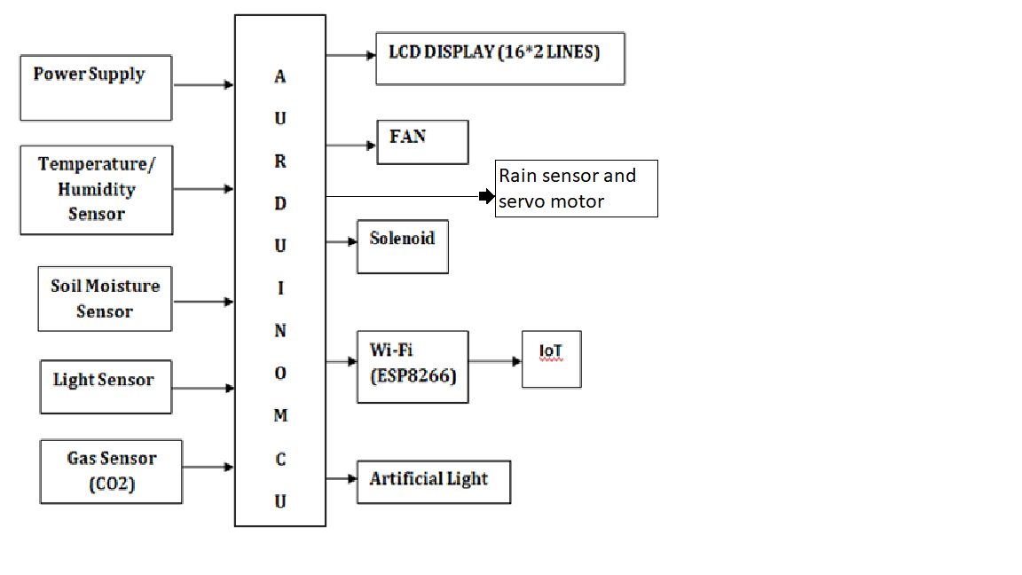

***Figure 3.1: Proposed system Architecture***

The above figure 3.1 shows the block diagram of Greenhouse monitor and control system. It contains temperature and humidity sensor, Soil moisture sensor, LDR sensor, Gas sensor, Rain Sensor, Wi-Fi (ESP8266), Bulb, Fan, Solenoid, Servo motor connected to Arduino UNO Microcontroller Unit. The Temperature sensor, senses the level of temperature, if it goes higher than 32 Degrees (Can be changed manually as needed) DC fan gets on and when the temperature goes less than 32 degrees the fan gets off.Soil moisturesensor, senses the water level as the level goes below 50 the water gets pumped on. The LDR sensor senses the light intensity in the surroundings. When the Light Intensity goes below 50 units it senses and switches on the light.

Air quality sensorsenses the levels of carbon dioxide (CO2) present within the greenhouse and alerts the Arduino if the level of co2. By this way it will become easy to monitor and control the system. Rain sensor senses the Rain fall and turns on the Servo motor (angle of rotation can be set manually as needed). With the help of HTTP protocol, the Node MCU module is connected to the wireless internet connection or through IoT platforms like ubidots.com.

The collected environmental parameters data sent to smartphones via online mode to the farmers to make the proper overlook on their fields, no matter how far they are just by using the IoT platform.

Greenhouse is such kind of house which has mainly two parts. One part is its structural building frame and other one is its covering material. Structural building frame may be made of iron rode or wooden structure and covering material may be glass or plastic sheet. For understanding greenhouse first of all we should have to know about what is greenhouse effect in greenhouse. When the light coming from sun entered from the covering material that is transparent for sun light and come into the greenhouse then energy coming from the sun in form of rays absorbed by the plants, soil and structure and this energy is trapped into the greenhouse. Infrared rays are very useful for the growth of plants so by using the greenhouse these infrared rays trapped into the greenhouse.[17] In this way overall energy inside the greenhouse increase and plant growth rate increase and plant growth are impressive.

Greenhouse protects and a controls environmental climate as plants are being planted inside the covered structural building frame. Mostly the farmers and gardener use manual system for irrigation (watering) to their plant in the farms, garden and also in the greenhouse. Such kind of manual system is inefficient, due to the loss of water and also power loss if water pump is being used for the supply of water. In order to overcome such kind of problem, automatic greenhouse should be used.

For every plant growth there are four major Environmental plant growth factors which are Light, Temperature, Humidity and Soil Moisture. This fully controlled greenhouse system will fully control and monitors light intensity, soil moisture and air humidity using Arduino mega and Wi-Fi modules. Every plant has its own plant profile. Plant profile of every plant say about what kind of environmental factors and what ranges of these factors are suitable for the plenty growth of plant. For example, plant profile of winder plants is quietly different from the plant profile of summer plants.

First of all, we load the plant profile that is its environmental parameters into the system. This system has sensors, actuators (controlling devices) and Wi-Fi. Environmental factors will sense by sensors and display on LCD. If any one of the parameter changes with respect to the plant profile, then Arduino will actuate the respective device for that parameter and will keep it turned on until it reached to its required range that is into the set of environmental parameters loaded into the system. As when the parameter reached to the required range then the Arduino will turn off that device.

The above Figure 3.2 show that greenhouse system is in bi-directional communication with the main unit and main unit also in bi-directional communication with the Ubidots through Wi-Fi module and Wi-Fi module in bi-directional with the Mobile. Whenever any parameter changes in greenhouse it communicates with the main unit. Main unit then perform some action for maintaining the parameter. Wi-Fi module communicate with the main unit and take all information about the current parameters of greenhouse and give information about all parameters on Mobile module/PC either by displaying the data or sending a SMS.

1. First of all, we interface our sensors with Arduino.
2. Then we interface LCD 16*2 with Arduino.
3. Then we design a power bank for our plants and Arduino.
4. Then we interface Wi-Fi with Arduino in order to get updates related to our parameters.
5. In parallel we also work on our prototypes for Controlled Greenhouse system.
6. Finally, we integrate all our modules.

**3.3 COMPONENTS USED**

**Hardware**

* Arduino Controller
* Wi-Fi Module
* Temperature /humidity sensor
* Soil Moisture Sensor
* Light Sensor
* LCD Display
* FAN
* Solenoid
* Rain sensor

**Software**

* Arduino IDE
* Embedded C Language
* Ubidots.com

**CHAPTER 4**

**HARDWARE TOOLS**

**4.1 ARDUINO MICROCONTROLLER**

The Arduino Uno is a microcontroller board in context of the ATmega328.

It has 14 electronic data/yield pins (of which 6 can be utilized as PWM yields), 6 clear data sources, a 16 MHz stylish resonator, a USB association, a power jack, an ICSP header, and a reset get.[18] It contains everything foreseen that would help the microcontroller; just interface it to a PC with a USB association or power it with an AC-to-DC connector or battery to begin.

The Uno contrasts from every last going before board in that it doesn't utilize the FTDI USB-to-serial driver chip. Or on the other hand perhaps, it consolidates the Atmega16U2 (Atmega8U2 up to change R2) modified as a USB to-serial converter.

Revision3 of the board has the running with new parts:

* **Pin out:** included SDA and SCL pins that are close to the AREF stick and two other new follows set close to the RESET stick, the IOREF that enable the shields to adapt to the voltage gave from the board. In future, shields will be extraordinary both with the board that utilization the AVR, which work with 5V and with the Arduino Due that work with 3.3V. The second one is a not related stick that is held for future purposes.
* At mega 16U2 supplant the 8U2.
* "Uno" recommends one in Italian and is named to stamp the best in class arriving of Arduino 1.0. The Uno and modification 1.0 will be the reference variants of Arduino, advancing. The Uno is the most recent in a development of USB Arduino sheets, and the reference display for the Arduino sort out; for an association with past modification.

**Arduino board**

Arduino is a model stage (open-source) in light of an easy to-use hardware and programming.[20] It incorporates a circuit board, which can be modified (suggested as a microcontroller) and a possible programming called Arduino IDE (Integrated Development Environment), which is worn to casing and exchange the PC code to the physical board. The key sections are: Arduino sheets can read fundamental or pushed data signals from different sensors and change it into a yield, for instance, starting a motor, turning LED on/off, join to the dull and diverse obvious exercises.

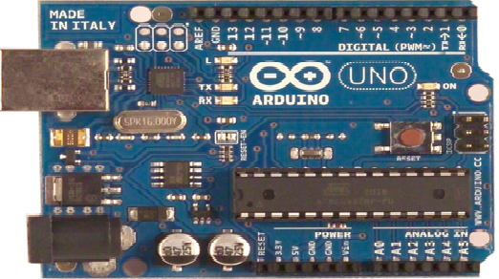

***Figure 4.1: Arduino Board***

You can deal with your board obliges as far as expert vocation a procedure of rules to the microcontroller on the board by methods for Arduino IDE (recommended as exchanging programming). Not at all like most before programmable circuit sheets, Arduino does not require an extra piece of hardware (called a thing diagram) with a particular veritable objective to stack another code onto the board. You can basically use a USB relate. Also, the Arduino IDE uses a streamlined difference in C++, making it less requesting to appreciate how to program. Finally, Arduino gives a traditional bundling factor that breaks the parts of the cut back scale controller into a more open package.

**ATmega328P-PU with Arduino Boot loader**

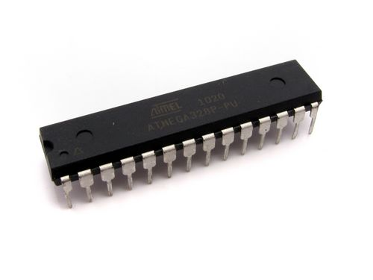

***Figure 4.2: ATmega328P-PU***

**Description**

The name says everything on this one. An Atmega328 in DIP bundle, pre-stacked with the Arduino (16MHz) Boot loader. This will engage you to utilize Arduino code in your especially presented connects without using a genuine Arduino board.

To get this chip working with Arduino IDE, you will require an outside 16MHz significant stone or resonator, a 5V supply, and a serial association. On the off chance that you are not content with doing this, we propose acquiring the Arduino Duemilanove board that has these merged with the board.

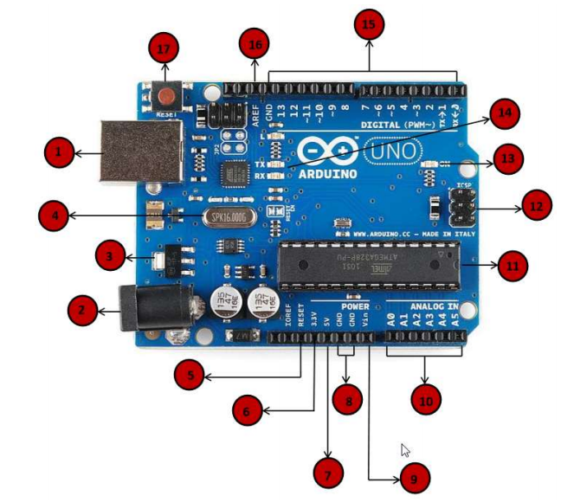

***Figure 4.3: Pin Description of Arduino***

1. **Power USB:** Arduino board can be engaged by using the USB interface from your PC. You should basically relate the USB interface with the USB union (1).

2. **Power (Barrel Jack):** Arduino sheets can be filled particularly from the AC mains control supply by assistant it to the Barrel Jack (2).

3. **Voltage Regulator:** The most distant purpose of the voltage controller is to control the voltage given to the Arduino board and parity the DC voltages used by the processor and diverse areas.

4. **Gem Oscillator:** The gainful stone oscillator helps Arduino in overseeing time issues. How does Arduino discover time? The most ideal reaction is, by using the noteworthy stone oscillator. The number engraved over the Arduino critical stone is 16.000H9H. It reveals to us that the repeat is 16,000,000 Hertz or 16 MHz

5. **Arduino Reset**: You can reset your Arduino board, i.e., start your program from the most reliable beginning stage. You can reset the UNO board in two different ways. Regardless, by using the reset get (17) on the board. Second, you would interface have the ability to an outside reset catch to the Arduino stick named RESET (5).

6,7,8,9 Pins (3.3, 5, GND, Vin) 3.3V (6): Supply 3.3 yield volt

* 5V (7): Supply 5 yield volt
* Most of the parts used with Arduino board works fine with 3.3-volt 5-volt GND (8) (Ground): There are a few GND sticks on the Arduino, any of which it tends to be used to ground your circuit. Vin (9): This stick in like way can be used to control the Arduino board from an outside power source, like AC mains control supply.

6. **Direct sticks:** The Arduino UNO board has five clear data pins A0 through A5. These pins can read the flag from a reasonable sensor like the moisture sensor or temperature sensor and change over it into an electronic regard that can be broke down by the chip.

7. **Primary Controller:** Each Arduino board has its own specific microcontroller (11). You can remember it as the cerebrum of your board. The essential IC (joined circuit) on the Arduino is somewhat not definitely the equivalent as board to board. The microcontrollers are generally of the ATMEL Company. You ought to perceive what IC your ban has before stacking another program from the Arduino IDE. This information is open on the most astounding explanation behind the IC. For more bits of finding out about the IC movement and purposes of restriction, you can propose the data sheet.

8. **ICSP stick**: For the most part, ICSP (12) is an AVR, an unassuming programming header for the Arduino containing MOSI, MISO, SCK, RESET, VCC, and GND. It is as frequently as conceivable proposed as a SPI (Serial Peripheral Interface), which could be considered as an "extension" of the yield. If all else fails, you are slaving the yield contraption to the expert of the SPI transport.

9. **Power LED pointer:** This LED ought to light up when you relate your Arduino to a power source to demonstrate that your blockade is empowered certainly. If this light does not turn on, by then there is a vital issue with the affiliation.

10. **TX and RX LEDs:** On your board, you will find two names: TX (transmit) and RX (get). They appear in two places on the Arduino UNO board. Regardless, at the robotized pins 0 and 1 display the pins accountable for sequential correspondence. Second, the TX and RX drove (13). The TX drove flashes with different speed while sending the sequential data. The speed of shooting depends on the baud rate used by the board. RX flashes in the midst of the getting method.

11. **Computerized I/O:** The Arduino UNO board has 14 electronic I/O pins (15) (of which 6 give PWM) (Pulse Width Modulation) yield. These pins can be dealt with to fill in as data electronic pins to look at procedure for speculation regards (0 or 1) or as forefront yield pins to drive particular modules like LEDs, exchanges, et cetera. The pins stamped "~" can be used to make PWM.

12. **AREF:** Remain for Analog Reference. It is on occasion, used to set an external reference voltage (in the region of 0 and 5 Volts) past what many would consider attainable for the reasonable data stick.

**Pin diagram**

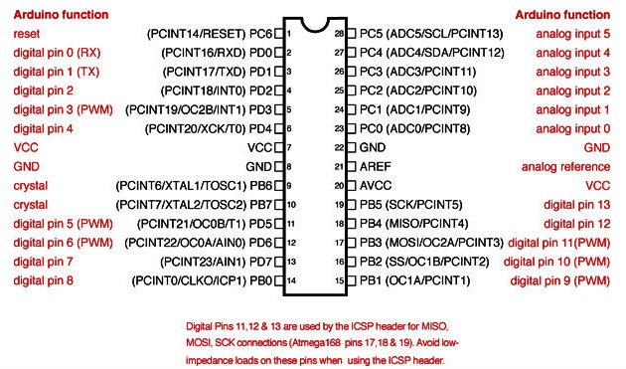

***Figure 4.4: Pin diagram of Arduino***

**SPECIFICATIONS**

Microcontroller ATmega328

Working Voltage 5V

Information Voltage(recommended) 7-12V

Info Voltage (limits) 6-20V

Computerized I/O Pins 14 (of which 6 give PWM yield)

Simple Input Pins 6

DC Current per I/O Pin 40 mA

DC Current for 3.3V Pin 50 mA

Streak Memory 32 KB (ATmega328) of which 0.5

KB utilized by bootloader

SRAM 2 KB (ATmega328)

EEPROM 1 KB (ATmega328)

Clock Speed 16 MHz

**4.1 TEMPARTURE AND HUMIDITY SENSOR (DHT11).**

Temperature sensor measures the temperature of the solar panel as we know the power generated by solar panel is directly related to temperature at the panel i.e. if temperature is high at panel, then the voltage current generated is also more or vice versa. Therefore, measurement of temperature is necessary which is done by temperature sensor module dht11.

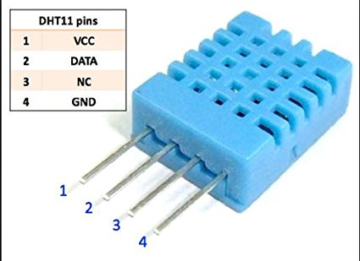

***Figure 4.5: Temp & Humidity Sensor***

DHT11 Temperature and Humidity Sensor include a temperature and stickiness sensor complex with an adjusted computerized flag yield. By utilizing the selective advanced flag securing strategy and temperature and dampness detecting innovation, it guarantees high unwavering quality and astounding long haul soundness.[16] This sensor incorporates a resistive-type moistness estimation part and a NTC temperature estimation segment, and interfaces with an elite 8-bit microcontroller, offering amazing quality, quick reaction, hostile to impedance capacity and cost-viability. This unit is made up of temperature sensor. It is a linear sensor with sensitivity of 10mV per degree Celsius. Its voltage output is directly proportional to temperature.

The two parameters are related by the formula:

T = 100 × Vout Where T = temperature in degree Celsius and Vout = voltage in volts

For Measuring Temperature here, we have used temperature sensor that is gives 10 mV for every 1 degree Celsius. Circuitry is simple for this.

DHT11 sensor measures and provides humidity and temperature values serially over a single wire. It can measure the relative humidity in percentage (20 to 90% RH) and temperature in degree Celsius in the range of 0 to 50°C. It has 4 pins; one of which is used for data communication in serial form. Pulses of different TON and TOFF are decoded as logic 1 or logic 0 or start pulse or end of the frame. For more information about the DHT11 sensor and how to use it, refer to the topic [DHT11 sensor](https://www.electronicwings.com/sensors-modules/dht11) in the sensors and modules topic.

**Specifications**

* Operating Voltage: 3.5V to 5.5V.
* Operating current: 0.3mA (measuring) 60uA (standby)
* Output: Serial data.
* Temperature Range: 0°C to 50°C.
* Humidity Range: 20% to 90%
* Resolution: Temperature and Humidity both are 16-bit.
* Accuracy: ±1°C and ±1%

**4.2 LDR SENSOR (LIGHT SENSOR)**

A Light Dependent Resistor (LDR) is also called a photo resistor or a cadmium sulfide (CdS) cell. It is also called a photoconductor. It is basically a photocell that works on the principle of photoconductivity. The passive component is basically a resistor whose resistance value decreases when the intensity of light decreases. This [optoelectronic device](https://www.circuitstoday.com/optoelectronic-devices) is mostly used in light varying sensor circuit, and light and dark activated switching circuits.[17] Some of its applications include camera light meters, street lights, clock radios, light beam alarms, reflective smoke alarms, and outdoor clocks.

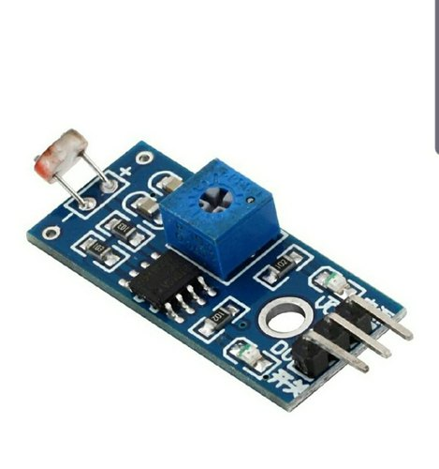

[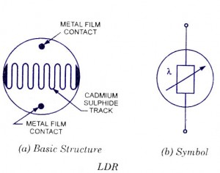](https://www.circuitstoday.com/wp-content/uploads/2009/08/ldr-light-dependent-resistor.jpg)

***Figure 4.6: LDR Sensor Module***

**LDR Structure and Working**

The basic structure of an LDR is shown above figure 4.2.

The snake like track shown above is the Cadmium Sulphide (CdS) film which also passes through the sides. On the top and bottom are metal films which are connected to the terminal leads. It is designed in such a way as to provide maximum possible contact area with the two metal films. The structure is housed in a clear plastic or resin case, to provide free access to external light. As explained above, the main component for the construction of LDR is cadmium Sulphide (CdS), which is used as the photoconductor and contains no or very few electrons when not illuminated. In the absence of light, it is designed to have a high resistance in the range of mega ohms. As soon as light falls on the sensor, the electrons are liberated and the conductivity of the material increases. When the light intensity exceeds a certain frequency, the photons absorbed by the semiconductor give band electrons the energy required to jump into the conduction band.[18] This causes the free electrons or holes to conduct electricity and thus dropping the resistance dramatically (< 1 Kiloohm).

The equation to show the relation between resistance and illumination can be written as

R = A.E^a

Where E – Illumination (lux)

R – Resistance (Ohms)

A,a – constants

The value of ‘a’ depends on the CdS used and on the manufacturing process. Values usually range between 0.7 and 0.9.

**Advantages**

LDR’s are cheap and are readily available in many sizes and shapes. Practical LDRs are available in a variety of sizes and package styles, the most popular size having a face diameter of roughly 10 mm. They need very small power and voltage for its operation.

**Specifications**

|  |  |
| --- | --- |
| **Parameter** | **Example Figures** |
| Max voltage @ 0 lux | 200V |
| Peak wavelength | 600nm |
| Min. resistance @ 10lux | 1.8kΩ |

***Table 4.1: Specifications of LDR Sensor***

**4.3 SOIL MOISTURE SENSOR**

The Soil Moisture Sensor is used to measure the volumetric water content of soil. This makes it ideal for performing experiments in courses such as soil science, agricultural science, environmental science, horticulture, botany, and biology.

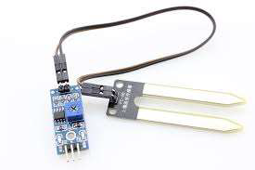

***Figure 4.7: Soil Moisture Sensor***

**Specifications:**

Operating Voltage: 3.3V to 5V DC

Operating Current: 15mA

Output Digital - 0V to 5V, Adjustable trigger level from preset

Output Analog - 0V to 5V

**4.4 RAIN SENSOR**

A sensor that is used to notice the water drops or rainfall is known as a rain sensor. This kind of sensor works like a switch. This sensor includes two parts like sensing pad and a sensor module. Whenever rain falls on the surface of a sensing pad then the sensor module reads the data from the sensor pad to process and convert it into an analog or digital output.[18] So, the output generated by this sensor is analog (AO) and digital (DO).

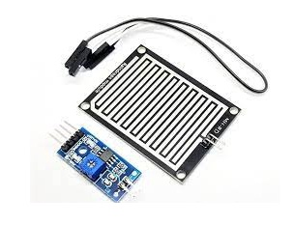

***Figure 4.8: Rain sensor module***

### Specifications

The specifications of rain sensors like different parameters with values are mentioned below.

* Operating voltage ranges from 3.3 to 5V
* The operating current is 15 mA
* The sensing pad size is 5cm x 4 cm with a nickel plate on one face.
* Comparator chip is LM393
* Output types are AO (Analog o/p voltage) & DO (Digital switching voltage)
* The length & width of PCB module 3.2cm x 1.4cm
* Sensitivity is modifiable through Trim pot
* Red/Green LED lights indicators for Power & Output

**4.5 GAS SENSOR (MQ4)**

This methane gas sensor detects the concentration of methane gas in the air and outputs its reading as an analog voltage [6]. The concentration sensing range of 300 ppm to 10,000 ppm is suitable for leak detection.  For example, the sensor could detect if someone left a gas stove on but not lit.

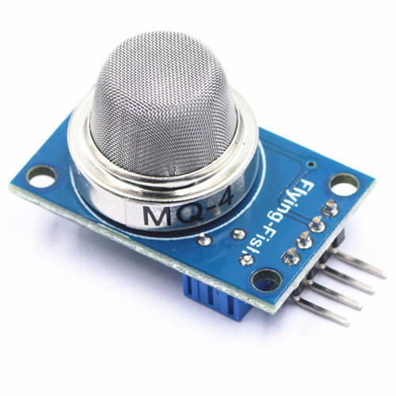

**Figure 4.9: MQ4 Sensor**

**Specifications**

Sensor Type Semiconductor.

Power requirements: VCC - 5V±0.1.

DO output: TTL digital 0 and 1 (0.1 and 5V)

AO output: 0.1-0 .3 V (relative to pollution), the maximum concentration of a voltage of about 4V.

Detection Gas: Natural gas/Methane

**4.6 WI-FI (ESP8266)**

ESP8266 Wi-Fi module is low-cost standalone wireless transceiver that can be used for end-point IoT developments. ESP8266 Wi-Fi module enables internet connectivity to embedded applications. It uses TCP/UDP communication protocol to connect with server/client.

**Wi-Fi**  is a technology for [wireless local area networking](https://en.wikipedia.org/wiki/Wireless_LAN) with devices based on the [IEEE 802.11](https://en.wikipedia.org/wiki/IEEE_802.11) standards. *Wi-Fi* is a trademark of the [Wi-Fi Alliance](https://en.wikipedia.org/wiki/Wi-Fi_Alliance), which restricts the use of the term *Wi-Fi Certified* to products that successfully complete interoperability certification testing. Devices that can use Wi-Fi technology include personal computers, video-game consoles, [phones](https://en.wikipedia.org/wiki/Smartphone) and [tablets](https://en.wikipedia.org/wiki/Tablet_computer), digital cameras, [smart TVs](https://en.wikipedia.org/wiki/Smart_TV), digital audio players and modern printers. Wi-Fi compatible devices can connect to the Internet via a WLAN and a [wireless access point](https://en.wikipedia.org/wiki/Wireless_access_point). Such an access point (or [hotspot](https://en.wikipedia.org/wiki/Hotspot_(Wi-Fi))) has a range of about 20 meters (66 feet) indoors and a greater range outdoors. Hotspot coverage can be as small as a single room with walls that block radio waves, or as large as many square kilometers achieved by using multiple overlapping access points.

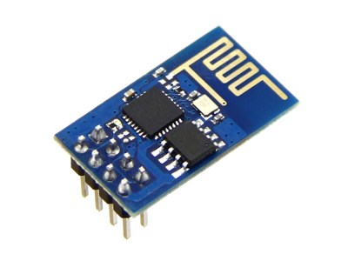

***Figure 4.10: Wi-Fi (ESP8266)***

The ESP8266 is a low-cost. The chip first came to the attention of western [makers](https://en.wikipedia.org/wiki/Maker_culture) in August 2014 with the ESP-01 module, made by a third-party manufacturer, Ai-Thinker. This small module allows microcontrollers to connect to a Wi-Fi network and make simple TCP/IP connections using [Hayes](https://en.wikipedia.org/wiki/Hayes_command_set)-style commands. However, at the time there was almost no English-language documentation on the chip and the commands it accepted.[16] The very low price and the fact that there were very few external components on the module which suggested that it could eventually be very inexpensive in volume, attracted many hackers to explore the module, chip, and the software on it, as well as to translate the Chinese documentation.

**Interfacing diagram**

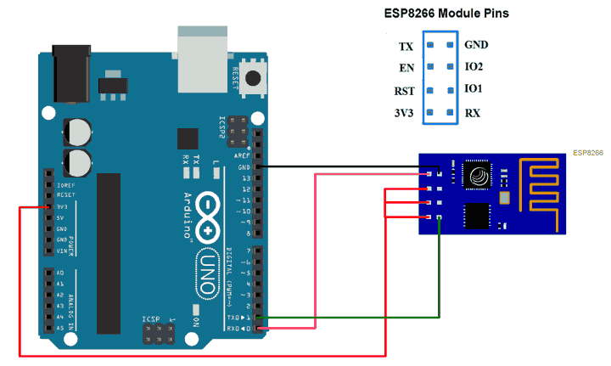

***Figure 4.11: Interfacing with Arduino***

**TCP Client using ESP8266 Wi-Fi Module**

Let’s program Arduino UNO to configure ESP8266 Wi-Fi module as TCP Client and Receive/Send data from/to Server using WIFI. Here, we are using Thing speak server for TCP Client demo purpose. Things peak is an open IOT platform where anyone can visualize and analyze live data from their sensor devices.

**Wi-Fi Pin Out**

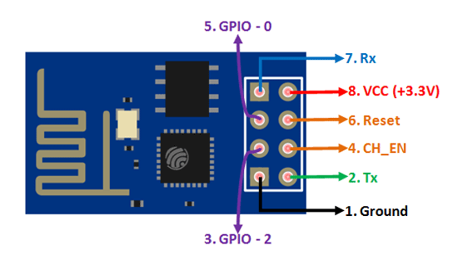

***Figure 4.12: Wi-Fi Pin Out***

**ESP8266 Pin Configuration**

|  |  |  |  |  |
| --- | --- | --- | --- | --- |
| **Pin Number** | **Pin Name** | **Alternate Name** | **Normally used for** | **Alternate purpose** |
| 1 | Ground | - | Connected to the ground of the circuit | - |
| 2 | TX | GPIO – 1 | Connected to Rx pin of programmer/UC to upload program | Can act as a General-purpose Input/output pin when not used as TX |
| 3 | GPIO-2 | - | General purpose Input/output pin | - |
| 4 | CH_EN | - | Chip Enable – Active high | - |
| 5 | GPIO - 0 | Flash | General purpose Input/output pin | Takes module into serial programming when held low during start up |
| 6 | Reset | - | Resets the module | - |
| 7 | RX | GPIO - 3 | General purpose Input/output pin | Can act as a General-purpose Input/output pin when not used as RX |
| 8 | Vcc | - | Connect to +3.3V only |  |
|  |  |  |  |  |

***Table 4.2: ESP8266 Pin Configuration***

**ESP8266-01 Features**

* Low cost, compact and powerful Wi-Fi Module
* Power Supply: +3.3V only
* Current Consumption: 100mA
* I/O Voltage:  3.6V (max)
* I/O source current: 12mA (max)
* Built-in low power 32-bit MCU @ 80MHz
* 512kB Flash Memory
* Can be used as Station or Access Point or both combined
* Supports Deep sleep (<10uA)
* Supports serial communication hence compatible with many developments’ platform like Arduino
* Can be programmed using Arduino IDE or AT-commands or Lua Script

**Use Of ESP8266-01**

The ESP8266 is a very user friendly and low-cost device to provide internet connectivity to your projects. The module can work both as a Access point (can create hotspot) and as a station (can connect to Wi-Fi), hence it can easily fetch data and upload it to the internet making Internet of Things as easy as possible. It can also fetch data from internet using API’s hence your project could access any information that is available in the internet, thus making it smarter. Another exciting feature of this module is that it can be programmed using the Arduino IDE which makes it a lot more user friendly. However, this version of the module has only 2 GPIO pins (you can hack it to use up to 4 so you have to use it along with another microcontroller like [Arduino](https://components101.com/microcontrollers/arduino-uno), else you can look onto the more standalone ESP-12 or ESP-32 versions. So, if you are looking for a module to get started with IOT or to provide internet connectivity to your project then this module is the right choice for you.

**Ways to use the ESP8266 Module**

There are so many methods and IDEs available to with ESP modules, but the most commonly used on is the Arduino IDE. So let us discuss only about that further below. The ESP8266 module works with 3.3V only, anything more than 3.7V would kill the module hence be cautions with your circuits. The best way to program an ESP-01 is by using the FTDI board that supports 3.3V programming. If you don’t have one it is recommended to buy one or for time, being you can also use an Arduino board. One commonly problem that everyone faces with ESP-01 is the powering up problem. The module is a bit power hungry while programming and hence you can power it with a 3.3V pin on Arduino or just use a potential divider. So, it is important to make a small voltage regulator for 3.31v that could supply a minimum of 500mA. One recommended regulator is the [LM317](https://components101.com/lm317-pinout-equivalent-datasheet) which could handle the job easily. A simplified circuit diagram for using the ESP8266-01 module is given below

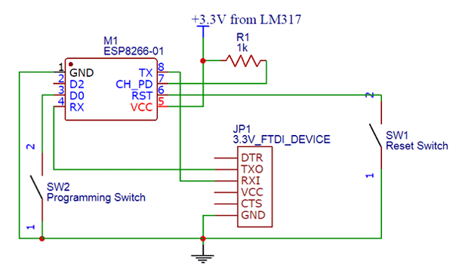

***4.13: ESP8266 Internal circuit***

The switch SW2 (Programming Switch) should be held pressed to hold the GPIO-0 pin to ground. This way we can enter into the programming mode and upload the code. Once the code is released the switch can be released.

**Applications**

* IOT Projects
* Access Point Portals
* Wireless Data logging
* Smart Home Automation
* Learn basics of networking
* Portable Electronics

Smart bulbs and Sockets

**4.7 WEB SERVER**

The essential capacity of a web server is to store, process and convey website pages to customers. The correspondence amongst customer and server happens utilizing the Hypertext Transfer Protocol (HTTP). Pages conveyed are most often HTML archives, which may incorporate pictures, templates and contents notwithstanding content substance. A client specialist, ordinarily a web program or web crawler, starts correspondence by making a demand for a particular asset utilizing HTTP and the server reacts with the substance of that asset or a blunder message if unfit to do as such. The asset is normally a genuine document on the server's optional stockpiling, yet this is not really the case and relies upon how the web server is actualized.

While the essential capacity is to serve content, a full execution of HTTP additionally incorporates methods for getting content from customers. This component is utilized for submitting web shapes, including transferring of records. Numerous non-specific web servers additionally bolster server-side scripting utilizing Active Server Pages (ASP), PHP, or other scripting dialects. This implies the conduct of the web server can be scripted in isolated records, while the genuine server programming stays unaltered. Generally, this capacity is utilized to create HTML archives progressively ("on-the-fly") rather than returning static reports. The previous is fundamentally utilized for recovering or altering data from databases. The last is commonly significantly quicker and all the more effortlessly reserved however can't convey dynamic substance.

Web servers are not just utilized for serving the World Wide Web. They can likewise be discovered installed in gadgets, for example, printers, switches, webcams and serving just a neighborhood organize. The web server may then be utilized as a piece of a framework for observing or overseeing the gadget being referred to. This normally implies no extra programming must be introduced on the customer PC, since just a web program is required (which now is incorporated with most working frameworks).

**4.9 LIQUID CRYSTAL DISPLAY**

LCD remains for Liquid Crystal Display. LCD is finding far reaching use supplanting LEDs (seven fragment LEDs or other multi section LEDs) as a result of the accompanying reasons:

1. The declining costs of LCDs.

2. The capacity to show numbers, characters and design. This is rather than LEDs, which are constrained to numbers and a couple characters.

3. Incorporation of an invigorating controller into the LCD, in this manner alleviating the CPU of the assignment of reviving the LCD. Interestingly, the LED must be revived by the CPU to continue showing the information.

4. Ease of programming for characters and design. These are utilized for indicting particular messages on a little scale LCD.

**Pins Functions**

|  |  |  |
| --- | --- | --- |
| Pin No | Function | Name |
| 1 | Ground (0V) | Ground |
| 2 | Supply voltage; 5V (4.7V – 5.3V) | Vcc |
| 3 | Contrast adjustment; through a variable resistor | VEE |
| 4 | Selects command register when low; and data register when high | Register Select |
| 5 | Low to write to the register; High to read from the register | Read/write |
| 6 | Sends data to data pins when a high to low pulse is given | Enable |
| 7 | 8-bit data pins | DB0 |
| 8 | DB1 |
| 9 | DB2 |
| 10 | DB3 |
| 11 | DB4 |
| 12 | DB5 |
| 13 | DB6 |
| 14 | DB7 |
| 15 | Backlight VCC (5V) | Led+ |
| 16 | Backlight Ground (0V) | Led- |

***Table 4.3: Pin functions of LCD***

**LCD screen**

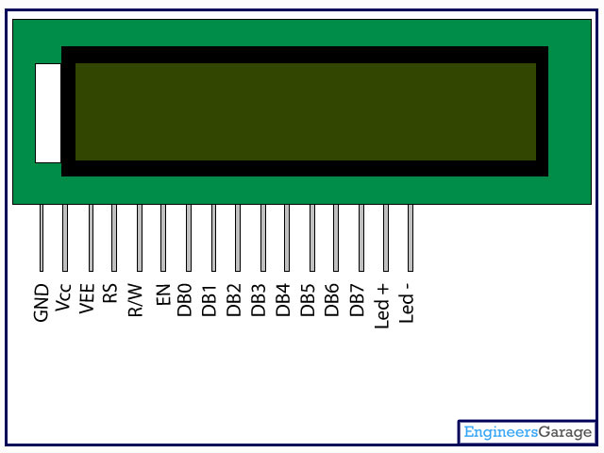

***4.14 LCD Pin diagram***

**LCD Basic Commands**

**Passage mode set order**

These summon sets cursor move bearing and show move ON/OFF. There are 4 conceivable capacity set commands;04, 05, 06, and 07. This order alters the course the cursor moves by setting the deliver counter to addition or decrement. This order is critical. In the event that you don't comprehend it you may not see anything or what you really needed to see on LCD screen. I have made 4 vivified gifs to show what the capacity set charge is about.

At the point when my companion Hakan Dereli needed to find out about LC shows I gave him a LC show and the 4*4 console that I utilized with my Z80 system. The console depends on a 74C922 chip and my circuit to change over the 4-bit information yield of the 74C922 to 8-bit data. It additionally has 3 different catches on it. This makes it extraordinary to explore different avenues regarding LCDs by entering charges/information physically. Hakan tried every single conceivable summon by sending every one of the numbers in the vicinity of 00h and FFh to the LCD to check whether there is an undocumented component and perceive how all charges function. He didn't discover anything undocumented, yet he noticed how LCD carries on after each capacity set summon. The following are the gifs to show those orders. To exhibit the impact of each capacity set charge it is expected that the LCDs beneath are 2*16 LC Displays with DD RAM deliver set to 8 and underline cursor ON. Take note of that when the deliver counter is set to DECREMENT, strings sent to the LCD will be imprinted backward request. A similar thing applies to the CG RAM, also.

• Clear Display.

• Cursor Home.

RS R/W DB7 DB6 DB5 DB4 DB3 DB2 DB1 DB0 0 1 * Returns the cursor to the home position (Address 0). Returns show to its unique state on the off chance that it was moved.

* Entry Mode Set.
* Display ON/OFF.
* Cursor and Display Shift.
* Function Set.
* Set CG RAM Address.
* Set DDRAM Address.

**16×2 LCD commands**

|  |  |
| --- | --- |
| **Code (Hex)** | **working of lcd commands** |
| 1 | Clear display screen |
| 2 | Return home |
| 4 | Decrement cursor (shift cursor to left) |
| 6 | Increment cursor (shift cursor to right) |
| 5 | Shift display right |
| 7 | Shift display left |
| 8 | Display off, cursor off |
| A | Display off, cursor on |
| C | Display on, cursor off |
| E | Display on, cursor blinking |
| F | Display on, cursor blinking |
| 10 | Shift cursor position to left |
| 14 | Shift cursor position to right |
| 18 | Shift the entire display to the left |
| 1C | Shift the entire display to the right |
| 80 | Force cursor to beginning to 1st line |
| C0 | Force cursor to beginning to 2nd line |
| 90 | Force cursor to beginning to 3rd line |
| D0 | Force cursor to beginning to 4th line |
| 38 | 2 lines and 5×7 matrix (8-bit mode) |
| 28 | 2 lines and 5×7 matrix (4-bit mode) |
| N | Next line |
| T | Tab |
| R | Enter |

***Table 4.4: 16×2 LCD commands***

**LCD Connection**

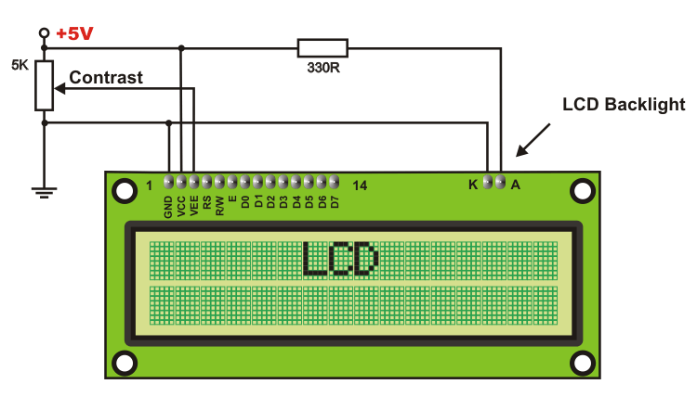

***Figure 4.15: LCD connection***

**LCD Initialization**

To instate LCD to the microcontroller the accompanying guideline and orders are to be insert into the capacities

• 0×38 is utilized for 8-bit information instatement.

• 0xFH for making LCD on and instating the cursor

• 0X6H for augmenting the cursor which will show another character in the LCD

• 0x1H for clearing the LCD.

• Sending information to the LCD: E=1; empower stick ought to be high

• RS=1; Register select ought to be high to write the information

• Placing the information on the information registers

• R/W=0; Read/Write stick ought to be low to write the information.

**4.10 POWER SUPPLY**

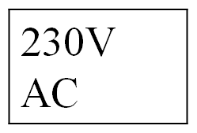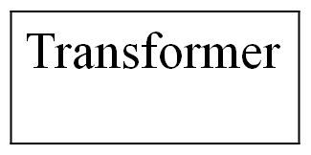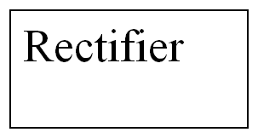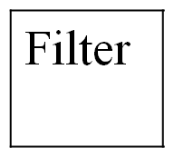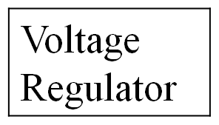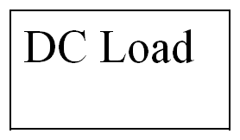

***Figure 4.16: Power Supply***

The information to the circuit is related from the arranged power supply. The a.c information i.e., 230v from the mains give is wind around the transformer to 12v and is lively to a rectifier.[5] The yield grabbed from the rectifier is a sore d.c voltage. Remembering the true objective to get an unmodified DC voltage, the yield voltage from the rectifier is supported to a channel to leave any AC parts introduce widely after refresh. Inevitably, this voltage is given to a voltage controller to get an immaculate unfaltering dc voltage.

The Arduino Uno can be filled by techniques for the USB association or with an outside power supply. The power source is picked consequently. Outside (non-USB) power can come either from an AC-to-DC connector (divider wart) or battery. The connector can be connected by ending a 2.1mm focus positive interface with the board's essentialness jack. Leads from a battery can be embedded in the Gnd and Vin stick headers of the POWER connector.

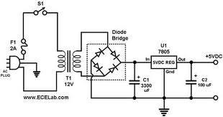

***Figure 4.17: Circuit diagram of LPC2148***

The board can wear down an outer supply of 6 to 20 volts. In the event that gave under 7V, regardless, the 5V stick may supply under five volts and the board might be unsafe. In the event that utilizing more than 12V, the voltage controller may overheat and hurt the board. The prescribed run is 7 to 12 volts.

**The power pins are as per the going with**

• VIN. The information voltage to the Arduino board when it's utilizing an outside power source (instead of 5 volts from the USB association or other supervised control source). You can supply voltage through this stick, or, if giving voltage by techniques for the power jack, get to it through this stick.

• 5V. The facilitated control supply used to control the microcontroller and differing parts on the board. This can come either from VIN by techniques for an on-board controller, or be given by USB or another planned 5V supply.

• 3V3. A 3.3-volt supply conveyed by the on-board controller. Most ludicrous current draw is 50 mA.

• GND. Ground pins.

**Transformer**

When in doubt, DC voltages are obliged to work diverse electronic apparatus and these voltages are 5/9/12 Volts. In any case these voltages can't be gotten arrange.

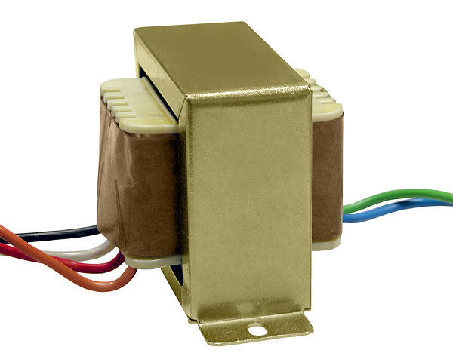

***Figure 4.18: Step-down transformer***

In this way the AC information open at the mains supply i.e., 230Volts is to be cut down to the obliged voltage level. This is done by a transformer. Along these lines, a wander down transformer is used to diminish the voltage to an obliged level.

**Rectifier**

The yield from the transformer is made sense of how to the rectifier. It changes over AC. into throbbing DC. The rectifier might be a half wave or a full wave rectifier. In this broaden, a phase rectifier is used by brilliance of its purposes of intrigue like awesome reliability and full wave change.



***Figure 4.19: Bridge rectifier***

**Filter**

Capacitive channel is used as a touch of this wander. It removes the swells from the yield of rectifier and smoothens the Dc. Yield got from this channel is relentless until the mains voltage and weight is kept up reliable. On the other hand, if both of the two is changed, Dc. voltage got starting at the present moment changes. Along these lines a controller is connected at the yield make.

**Voltage Controller**

A voltage controller is an electrical controller planned to thusly keep up a persevering voltage level. In this wind, control supply of 5v and 12v are required. Remembering the true objective to get these voltage levels, 7805 and 7812 voltage controllers are to be used.



***Figure 4.20: Voltage regulator***

**Memory**

The Atmega328 has 32 KB of glimmer memory for securing code (of which 0,5 KB is utilized for the boot loader); It has in like way 2 KB of SRAM and 1 KB of EEPROM.

**Communication**

The Arduino Uno has different workplaces for talking with a PC, another Arduino, or diverse microcontrollers. The ATmega328 gives UART TTL (5V) serial correspondence, which is available on electronic pins 0 (RX) and 1 (TX). An ATmega16U2 on the board channels this serial correspondence over USB and appears as a virtual com port to programming on the PC. The '16U2 firmware uses the standard USB COM drivers, and no 2xternal driver is required. Nevertheless, on Windows, an .info record is required. The Arduino programming consolidates a serial screen which empowers fundamental printed data to be sent to and from the Arduino board.[4] The RX and TX LEDs on the board will streak when data is being transmitted through the USB-to-serial chip and USB relationship with the PC (however not for serial correspondence on pins 0 and 1).

A Software Serial library thinks about serial correspondence on any of the Uno's propelled pins. The ATmega328 in like manner supports I2C (TWI) and SPI correspondence. The Arduino programming fuses a Wire library to streamline use of the I2C transport; see the documentation for purposes of intrigue. For SPI correspondence, use the SPI library.

**USB Over current Protection**

The Arduino Uno has a resettable polyfused that shields your PC's USB ports from shorts and overcurrent. Though most PCs give their own specific inside confirmation, the breaker gives an extra layer of security. If more than 500 mA is associated with the USB port, the circuit will normally break the relationship until the point that the short or over-load is removed.

**Physical Characteristics**

The best length and width of the Uno PCB are 2.7 and 2.1 inches independently, with the USB connector and power jack extending past the past estimation. Four screw holes empower the board to be joined to a surface or case. Note that the partition between electronic pins 7 and 8 is 160 mil (0.16"), not an even unique of the 100-mil scattering of exchange pins.

**4.11 INTERNET OF THINGS (IOT)**

The Internet of Things (IOT) is an arrangement of interrelated processing gadgets, mechanical and advanced machines, items, creatures or individuals that are furnished with novel identifiers and the capacity to exchange information over a system without expecting human-to-human or human-to-PC connection [18]. IOT is just the system of interconnected things/gadgets which are installed with sensors, programming, organize network and fundamental hardware that empowers them to gather and trade information making them responsive.

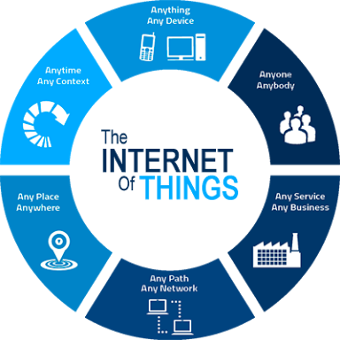

***Figure 4.21: IOT***

**Reasons For Becoming Internet of Things /IOT successful in The Coming Years**

As the media transmission segment is ending up broader and more effective, broadband web is generally accessible. With mechanical progression it is currently substantially less expensive to create important sensors with worked in Wi-Fi abilities making interfacing gadgets less exorbitant.

Most vital, the advanced mobile phone use has outperformed all as far as possible and media transmission segment is now chipping away at its toes to keep their clients fulfilled by enhancing their foundation. As IOT gadgets require no different correspondence than the current one building IOT tech is exceptionally shabby and very achievable. [18] Widely accessible, the cost of interfacing is diminishing, more gadgets are being made with Wi-Fi abilities and sensors incorporated with them, innovation costs are going down, and cell phone infiltration is soaring. These things are making an "impeccable tempest" for the IOT.

This is the idea of fundamentally interfacing any gadget with an on and off change to the Internet (as well as to each other). This incorporates everything from cell phones, espresso creators, clothes washers, earphones, lights, wearable gadgets and practically whatever else you can consider. The IOT is a monster system of associated "things" (which additionally incorporates individuals). The relationship will be between human individuals, human things, and things-things.

**The Impact on us**

The new control for what's to come will be, "Anything that can be associated, will be associated." But why for heaven's sake would you need such a significant number of associated gadgets conversing with each other? There are numerous cases for what this may look like or what the potential esteem may be. Say for instance you are enroute to a meeting; your auto could approach your date-book and right now know the best course to take. In the event that the activity is substantial your auto may send content to the next gathering advising them that you will be late. Imagine a scenario where your wake-up timer awakens you at 6 a.m. and after that informs your espresso creator to begin blending espresso for you? Imagine a scenario in which your office hardware knew when it was running low on provisions and consequently re-requested more. Consider the possibility that the wearable gadget you utilized as a part of the working environment could reveal to you when and where you were most dynamic and profitable and imparted that data to different gadgets that you utilized while working.

The Internet of Things, called the IOT for short, is another interconnection of innovation proclaimed as the following mechanical upset inferring radical change, interruption, and a totally new worldview for the planet. In particular, the Internet of Things is an expansion of the current associations amongst individuals and PCs to incorporate carefully associated "things."

These things measure and report information. This information can be straightforward numbers from a stationary or portable sensor, (for example, a temperature sensor), or more mind-boggling discoveries from gadgets that measure and report numerous information streams without a moment's delay. These propelled gadgets can even incite or impact the information they're measuring (an associated indoor regulator is a simple illustration.).

As indicated by Cisco, the IOT can possibly develop worldwide corporate benefits by 21% out of 2022. (Wim Elf rink, EVP Industry Solutions, Cisco) That means 10,000,000,000,000,000,000,000 bytes of information more than 18,200,000,000 associations.

**Advantages of IOT**

* Communication
* Robotization and Control
* Information
* Monitor
* Time
* Money
* Productive and Saves Time
* Spares Money
* Better Quality of Life

**Applications of IOT**

* Smart Cities
* Home Automation
* Modern Automation
* Wellbeing Monitoring
* Smart Environment

**CHAPTER-5**

**SOFTWARE IMPLEMENTATION**

**5.1 SOFTWARE REQUIREMENTS**

Arduino 1.0.6 software tools used to program microcontroller. The working of software tool is explained below in detail.

**Programming Microcontroller**

A compiler for an abnormal state dialect decreases generation time. To program the Arduino UNO microcontroller the Arduino is utilized. The writing computer programs is done entirely in the installed C dialect. Arduino is a suite of executable, open-source programming advancement devices for the microcontrollers facilitated on the Windows stage.

Arduino is a device for appearing well and good and control a greater amount of the physical world than your desktop PC. It's an open-source physical registering stage in view of a straightforward microcontroller board, and an improvement domain for composing programming for the board.

One of the challenges of programming microcontrollers is the restricted measure of assets the developer needs to manage. In PCs assets, for example, RAM and preparing speed are essentially boundless when contrasted with microcontrollers. Conversely, the code on microcontrollers ought to be as low on assets as could reasonably be expected

**5.2 ARDUINO COMPILER**

**Get an Arduino board and USB cable**

You additionally require a standard USB link (An attachment to B plug): the kind you would associate with a USB printer, for instance. (For the Arduino Nano, you'll require an A to Mini-B link.)

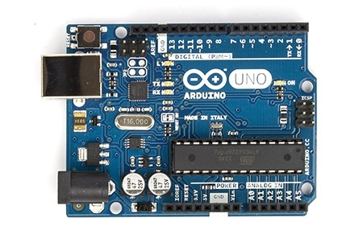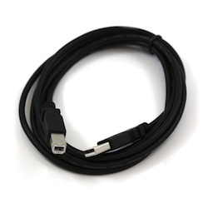

***Figure 5.1: Arduino board and USB cable***

**Connect the board**

The Arduino Uno, Mega, Duemilanove and Arduino Nano consequently draw control from either the USB association with the PC or an outer power supply. In case you're utilizing an Arduino Diecimila, you'll have to ensure that the board is configurered to draw control from the USB association. The power source is chosen with a jumper, a little bit of plastic that fits onto two of the three sticks between the USB and power jacks. Watch that it's on the two sticks nearest to the USB port. Associate the Arduino board to your PC utilizing the USB link. The green power LED (named PWR) ought to go on.



***Figure 5.2: Board Connections***

**Open the blink example**

Open the LED blink example sketch: File > Examples > 1.Basics > Blink**.**

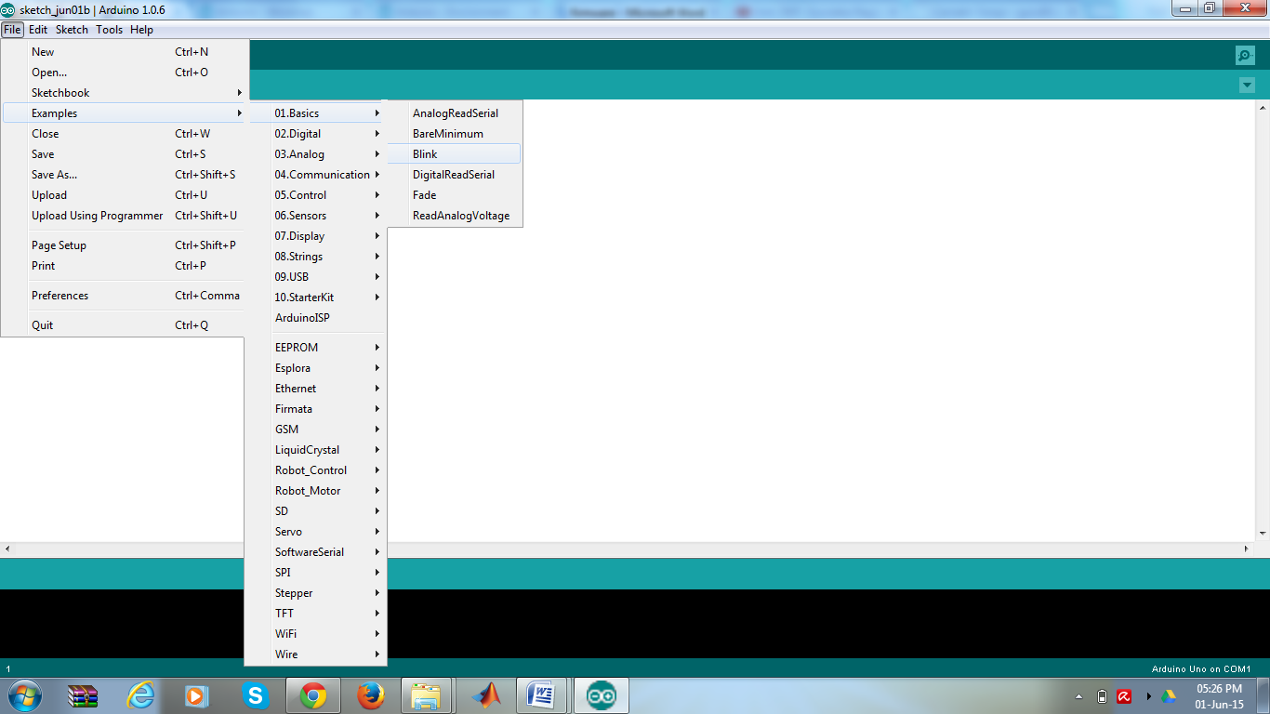

***Figure 5.3: Opening Blink Example***

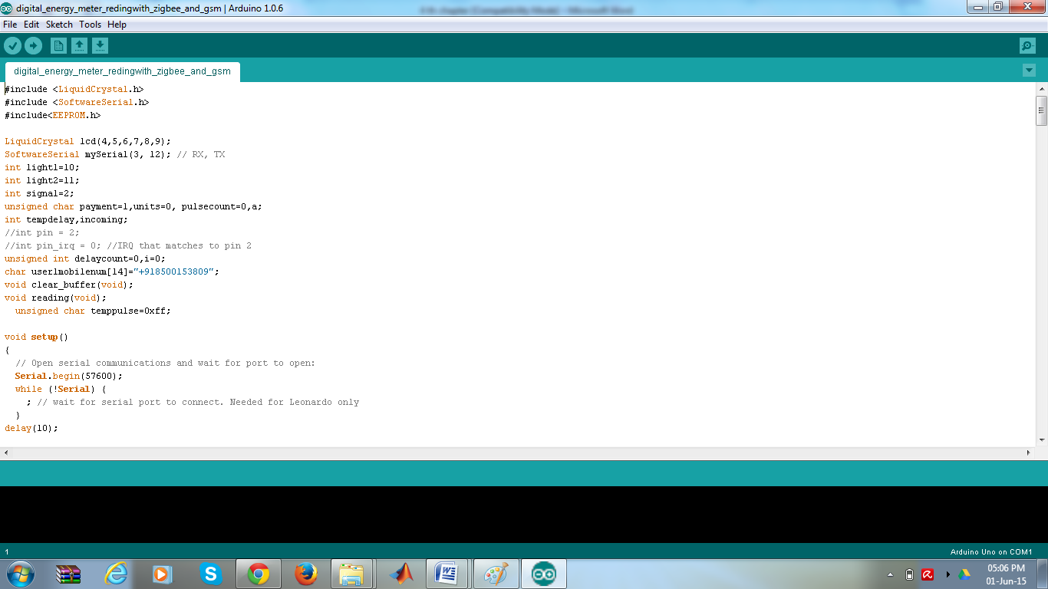

***Figure 5.4: Source Code Written in Arduino Compiler***

**Select your board**

You'll need to select the entry in the Tools > Board menu that corresponds to your Arduino.

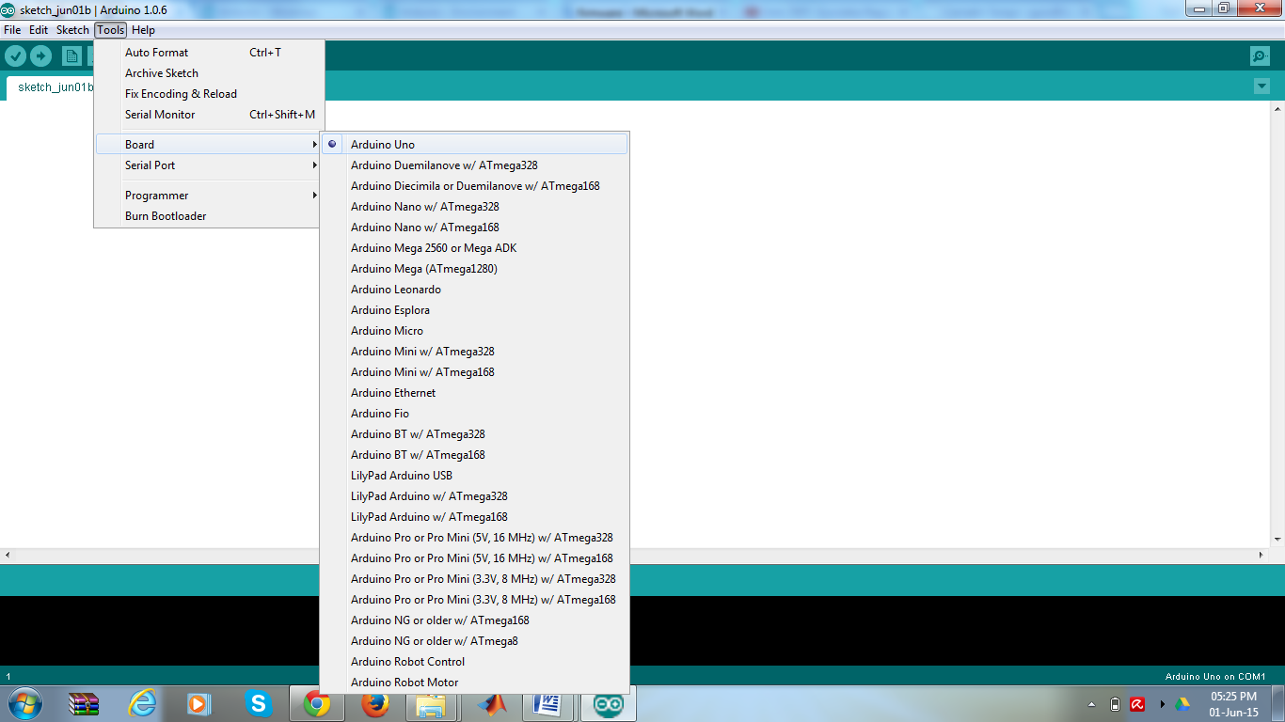

***Figure 5.5: Selecting an Arduino Uno***

**Writing Sketches**

Software written using Arduino are called sketches. These sketches are written in the text editor. Sketches are saved with the file extension. No. It has features for cutting/pasting and for searching/replacing text. The message area gives feedback while saving and exporting and also displays errors. The console displays text output by the Arduino environment including complete error messages and other information. The bottom right-hand corner of the window displays the current board and serial port. The toolbar buttons allow you to verify and upload programs, create, open, and save sketches, and open the serial monitor.

NB: Versions of the IDE prior to 1.0 saved sketches with the extension.pde. It is possible to open these files with version 1.0, you will be prompted to save the sketch with the.ino extension on save.

|  |  |
| --- | --- |
| http://arduino.cc/en/uploads/Guide/play.png | Check  Checks your code for mistakes. |
| http://arduino.cc/en/uploads/Guide/export.png | Transfer  Assembles your code and transfers it to the Arduino I/O board. See transferring beneath for subtle elements.  Note: If you are utilizing an outer software engineer, you can hold down the "move" key on your PC when utilizing this symbol. The content will change to "Transfer utilizing Programmer" |
| http://arduino.cc/en/uploads/Guide/new.png | New  Makes another draw. |
| http://arduino.cc/en/uploads/Guide/open.png | Open  Presents a menu of all the representations in your sketchbook. Clicking one will open it inside the present window.  Note: because of a bug in Java, this menu doesn't scroll; on the off chance that you have to open a portray late in the rundown, utilize the File | Sketchbook menu. |
| http://arduino.cc/en/uploads/Guide/save.png | Spare  Recoveries your outline. |
| http://arduino.cc/en/uploads/Guide/serial_monitor.png | Serial Monitor  Opens the serial screen... |

***Table 5.1: Writing Sketches***

Extra charges are found inside the five menus: File, Edit, Sketch, Tools, Help. The menus are setting delicate which implies just those things applicable to the work as of now being done are accessible.

**Select your serial port**

Select the serial gadget of the Arduino board from the Tools | Serial Port menu. This is probably going to be COM3 or higher (COM1and COM2 are typically saved for equipment serial ports). To discover, you can disengage your Arduino board and re-open the menu; the section that vanishes ought to be the Arduino board. Reconnect the board and select that serial port.

**Upload the program**

Before transferring you portray, you have to choose the right things from the Tools > Board and Tools > Serial Portmenus. The sheets are depicted beneath. On the Mac, the serial port is most likely something like/dev/tty. usbmodem241 On Windows, it's presumably COM1 or COM2 (for a serial board) or COM4, COM5, COM7, or higher (for a USB board) - to discover, you search for USB serial gadget in the ports segment of the Windows Device Manager. On Linux, it ought to be/dev/ttyUSB0, /dev/ttyUSB1 or comparable.

Once you've chosen the right serial port and board, press the transfer catch in the toolbar or select the Upload thing from the File menu. Current Arduino sheets will reset naturally and start the transfer. With more established sheets (pre-Diecimila) that need auto-reset, you'll have to press the reset catch on the board just before beginning the transfer. On most sheets, you'll see the RX and TX LEDs flicker as the portray is transferred. The Arduino condition will show a message when the transfer is finished, or demonstrate a blunder.

When you transfer a portray, you're utilizing the Arduino boot loader, a little program that has been stacked on to the microcontroller on your board. It enables you to transfer code without utilizing any extra equipment. The boot loader is dynamic for a couple of moments when the board resets; at that point it begins whichever outline was most as of late transferred to the microcontroller. The boot loader will squint the on-board (stick 13) LED when it begins (i.e., at the point when the board resets).

Presently, just tap the "Transfer" catch in the earth. Hold up a couple of moments - you should see the RX and TX leds on the board blazing. In the event that the transfer is fruitful, the message "Done transferring." will show up in the status bar. (Note: If you have an Arduino Mini, NG, or other board, you'll have to physically exhibit the reset catch on the board promptly before squeezing the transfer catch.)



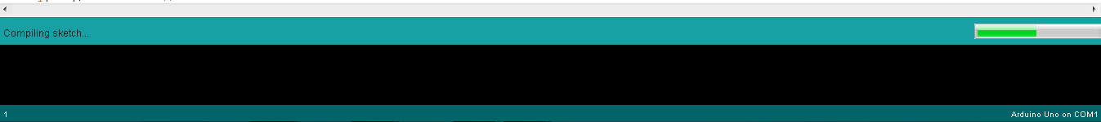

***Figure 5.6: Compilation under Process***

A couple of moments after the transfer completes, you should see the stick 13 (L) LED on the board begin to flicker (in orange). In the event that it does, congrats! You've gotten Arduino up-and-running.

**CHAPTER -6**

**PROJECT MANAGEMENT AND FINANCE FACTORS**

**Hardware:**

Since it is a hardware-based project, a green house is constructed with the following components

|  |  |  |
| --- | --- | --- |
| S.No | Component | Price |
| 1. | Arduino UNO | 599 |
| 2. | Temperature and Humidity sensor | 78 |
| 3. | Soil moisture sensor | 350 |
| 4. | Rain sensor | 140 |
| 5. | Air Quality sensor | 200 |
| 6. | Servo motor | 200 |
| 7. | LED | 150 |
| 8. | Green house | 1000 |
| 9. | LCD | 240 |
| 10. | Relay | 30 |
| 11. | Wi-Fi (ESP8266) | 300 |
| 12. | DC Fan | 150 |
| 13. | I2C Module | 100 |

***Table 6.1: components and price***

**Software:**

Arduino 1.0.6 software tools used to program microcontroller. This software is free source in internet and the software download internet usage is 25GB.

**Time Management:**

|  |  |
| --- | --- |
| **Phase** | **Description** |
| Phase 1 | Literature Survey: Spent on searching the area on which the project is to be done. Decided to do in MATLAB. |
| Phase 2 | Problem Identification and Study: Searched for reference papers and find a problem. The next four days was spent on analyzing the problem & studied the theoretical aspects of the project. |
| Phase 3 | Implementation of the proposed work: Spent on analyzing the tool boxes to be used for development of code. The project is broken down in to small sub sections such that each section was programmed and tested. |
| Phase 4 | Completion of project and Manuscript submission: Spent on the analyzing the results and arriving at conclusions. The rest of the time in this phase is spent on Manuscript submissions and final analysis of the work. |

The total duration of the project work is 15 weeks with 36 hours spent each week. This entire duration is divided into four phases with each phase taking Four weeks. The work done in each phase is shown in the below table

***Table 6.2: Time Management of project***

**CHAPTER 7**

**RESULTS**

**Experimental Results:**

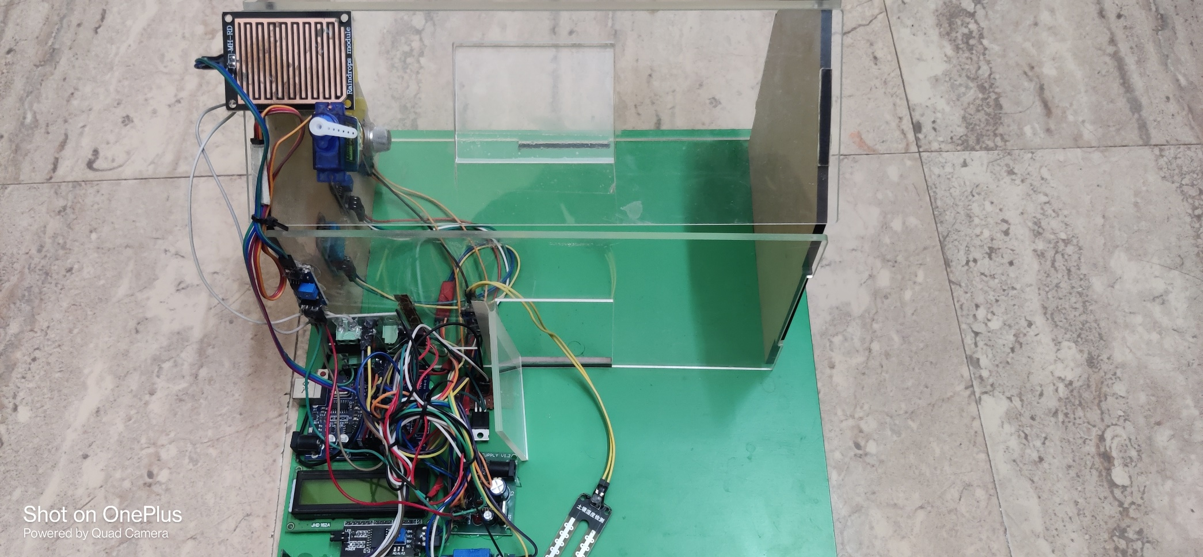Now-a-days unexpected Rains, sudden increase in the earth temperature leads to the destruction of overall crop which leads to the scarcity of food and huge loss to the farmer. So, with the help of construction of greenhouse monitoring and control system the loss can be minimized.

***Figure 7.1: Greenhouse Monitoring and Control System***

The above Figure 7.1 depicts the overall construction of greenhouse monitoring and control system.It contains temperature and humidity sensor, Soil moisture sensor, LDR sensor, Gas sensor, Rain Sensor, Wi-Fi (ESP8266), Bulb, Fan, Solenoid, Servo motor connected to Arduino UNO Microcontroller Unit.

**LDR Sensor:**

The LDR sensor senses the light intensity in the surroundings.The light intensity values can be changed manually as required .

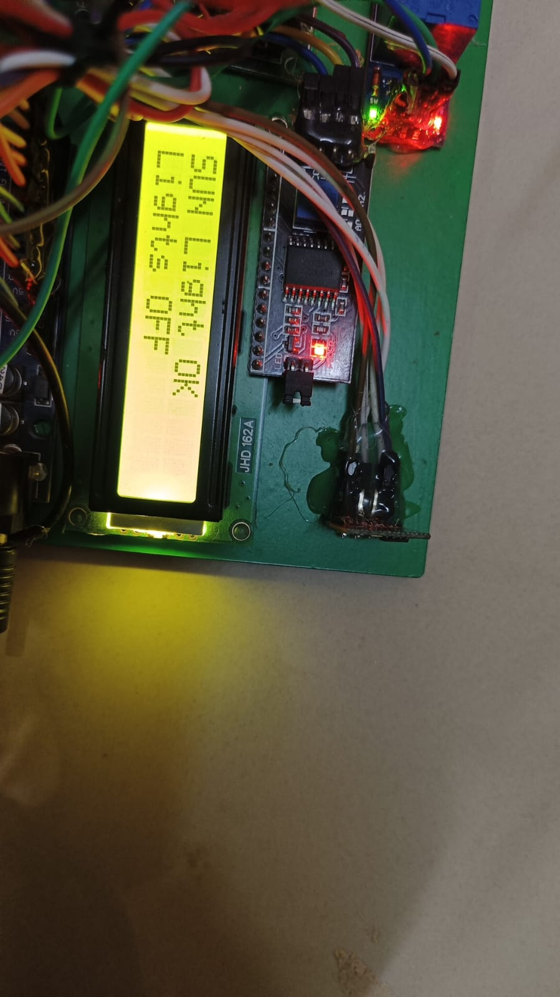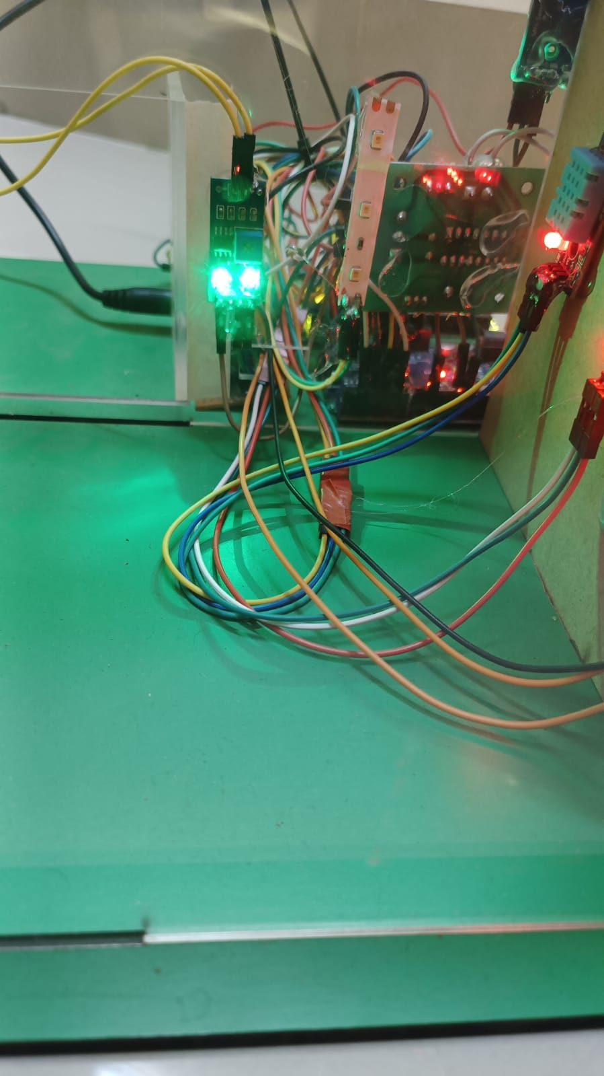**When Sunlight is OK:**



***Figure 7.2: working of LDR sensor when sunlight is ok***

The above Figure 7.2 shows the condition where the sunlight is Ok and the lights haven’t switched ON.

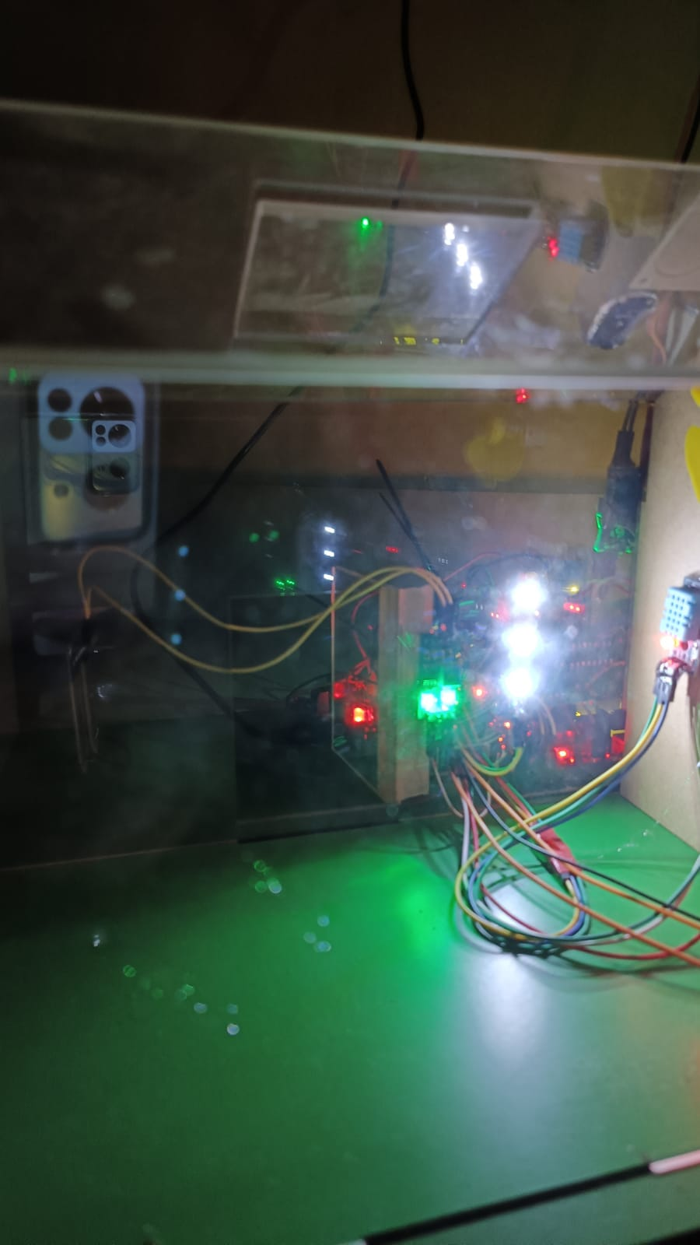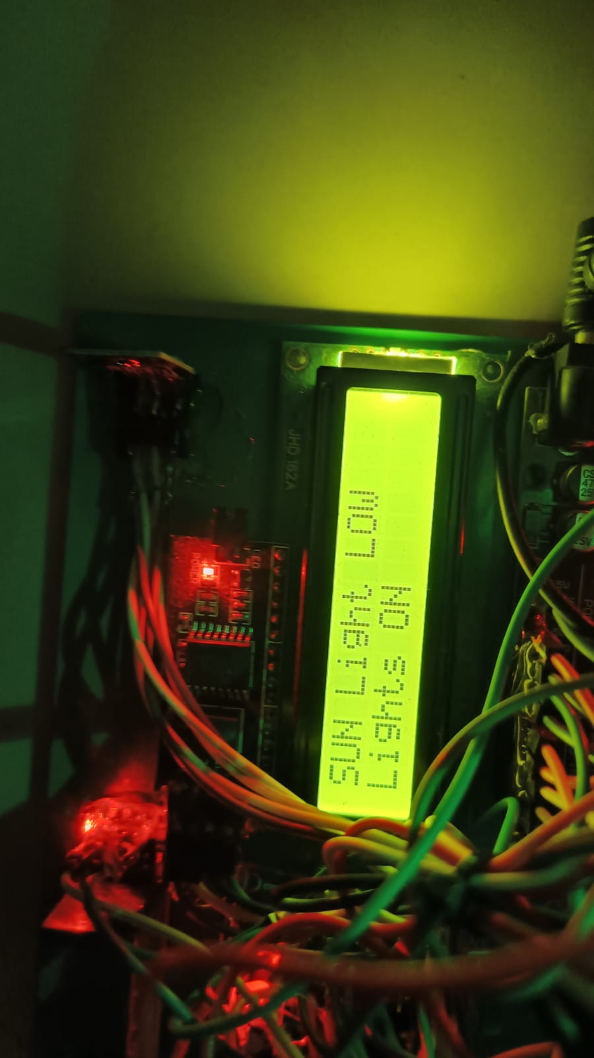**When Sun light is Low:**

**Figure 7.3: Working of LDR sensor when sunlight is low**

The above Figure 7.3 shows When the Light Intensity goes below 50 units it senses and switches on the light.

**Temperature Sensor:**

The Temperature sensor, senses the level of temperature in the green house system. These temperature values can be changed manually as per the requirement of the crop.

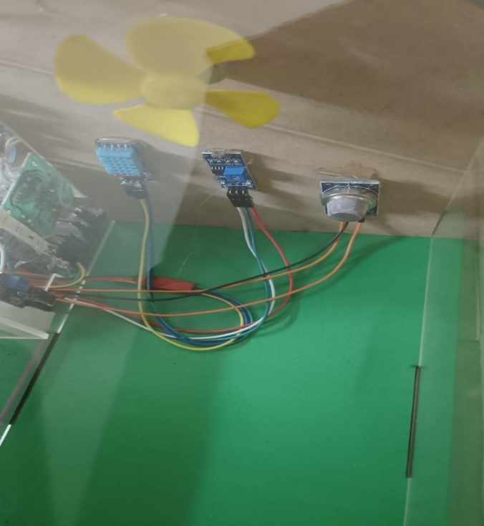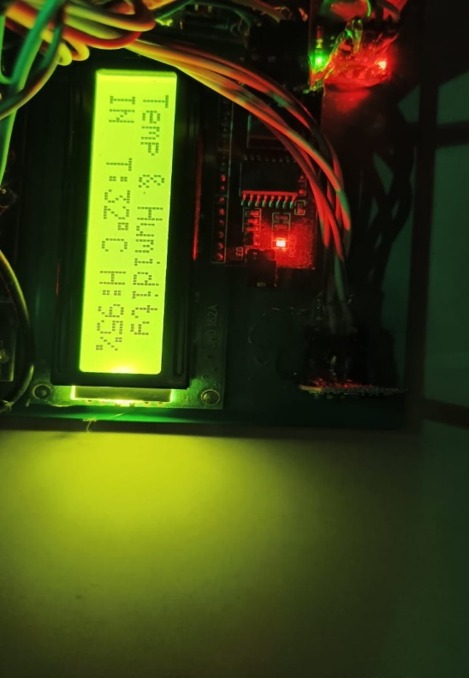

***Figure 7.4: Temperature and humidity values and working of DC fan accordingly***

The above Figure 7.4 shows the temperature is 32 degrees and the humidity values are above threshold so the fan is OFF.

**Soil Moisture Sensor:**

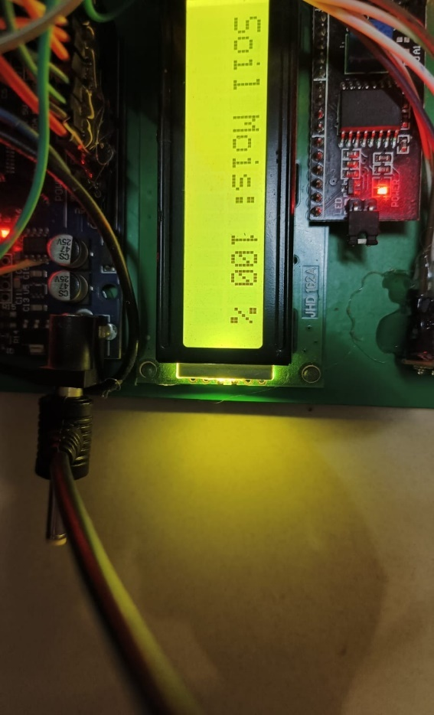Soil moisturesensor, senses the water level. The threshold moisture levels can be changed manually as per requirement for the crop.

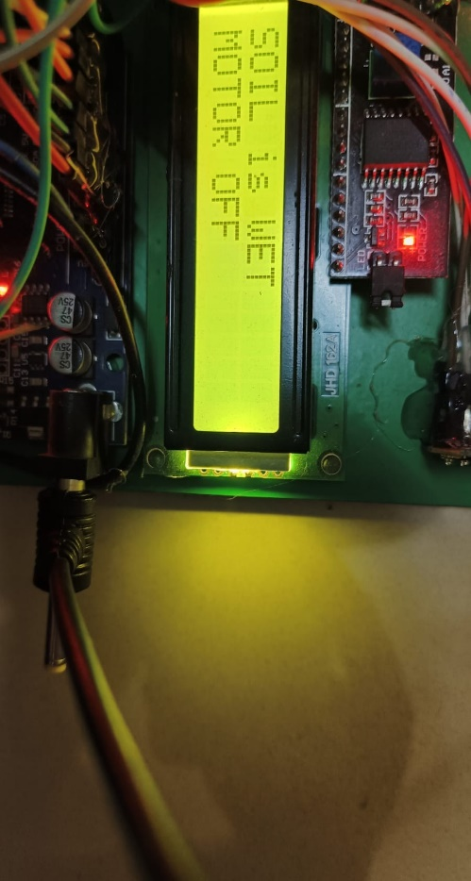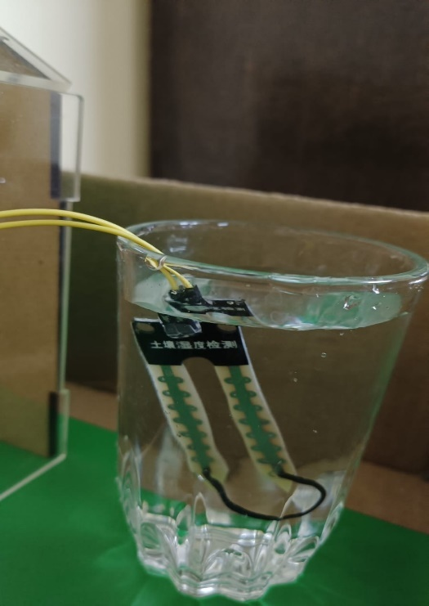

***Figure 7.5: Soil moisture sensor and values on LCD***

The above Figure 7.5 shows the situation where the moisture levels are high thus the outputs are soil is wet and motor is off.

**Rain Sensor and Servo Motor:**

Rain sensor senses the Rain fall and the servo motor changes it’s angle of rotation accordingly.

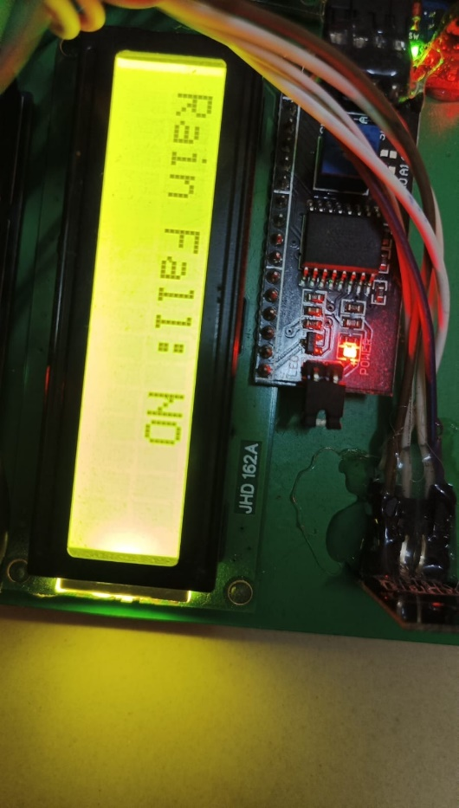

**When there is no rain fall:**

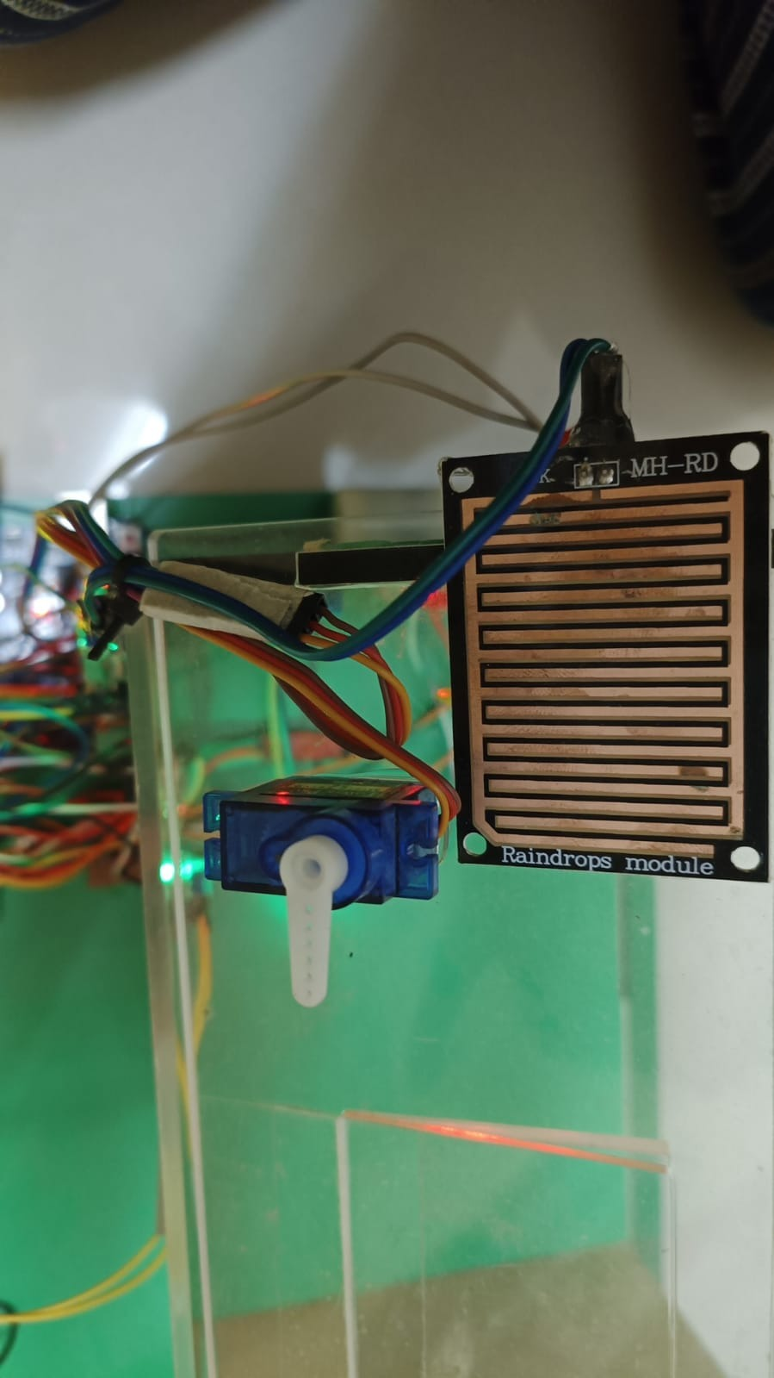

***Figure 7.6: Rain sensor working when there is no rainfall***

The above Figure 7.6 shows the condition where there is no rainfall and the servo motor is OFF.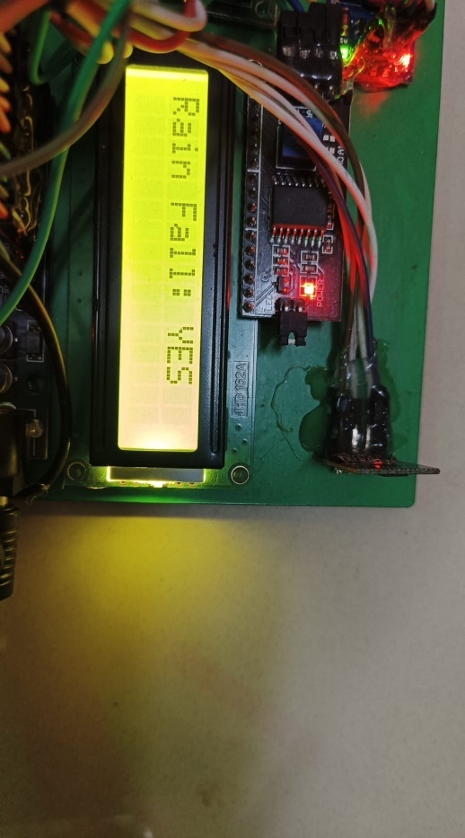

**When there is Rain fall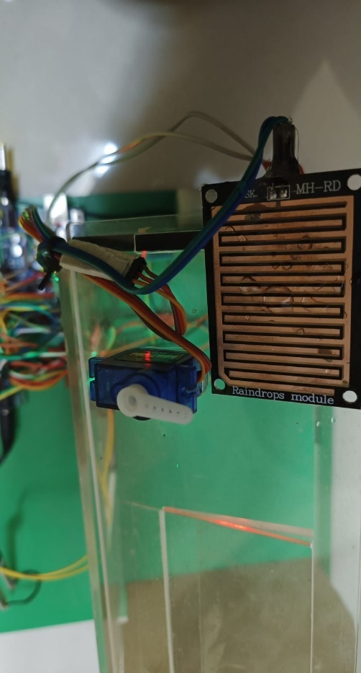:**

***Figure 7.7: Rain sensor working when there is rainfall***

The above Figure 7.7 shows the condition where there is Rainfall and the servo motor is rotated to 90 degrees.

**Air Quality sensor:**

The air quality sensor senses the amount of carbon dioxide and gives the value of overall value of air quality.

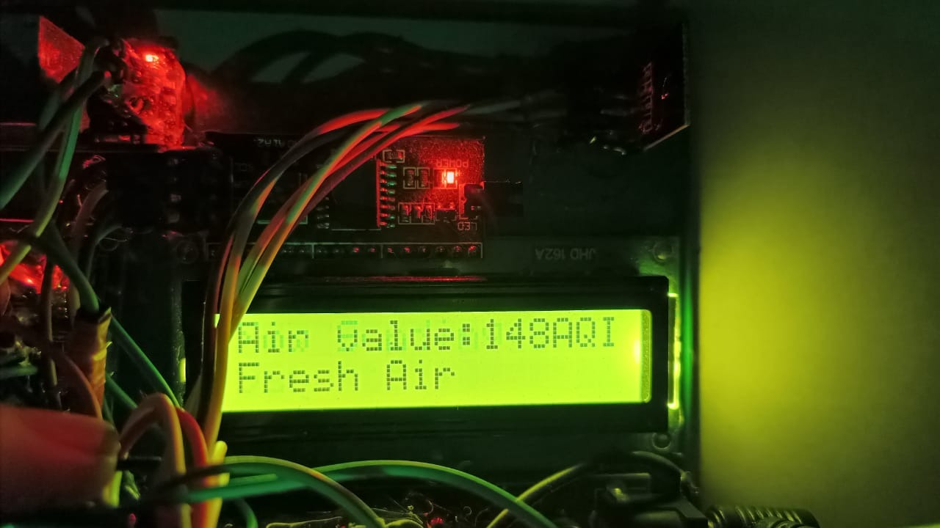

***Figure 7.8: Air quality values from air quality sensor.***

**7.2 ADVANTAGES**

1. water level management based on soil levels.
2. Plant Growth stability.
3. Less Cost of Implementation.
4. High Accuracy.
5. High yield of Crop Production
6. Changes get notified via SMS Alert.

**7.3 APPLICATIONS**

* Crop Water Management.
* Smart way of agriculture.
* Precision Farming
* Smart Greenhouses.
* Sensing and controlling of Climate Conditions.
* Food production and Safety.

**CONCLUSION**

Now that we have Embedded systems as a solution for every tech related problem, interfacing IOT with it gives much more improvement in the phase of technology development. This project is built in such a way to solve the greenhouse effect on the crops using both embedded system and IOT. Embedded system components like sensors, actuators, Microcontroller, software system etc., are used and an IOT system ubidots is used to transfer the data of the sensors and the corresponding actuators so that farmers can look into the data and correct their crops accordingly. More over through this IOT platform we can create alerts in the form of messages and Emails that report the sensor inputs and the actuators functioning. In this the farming becomes more flexible and easier. Also, farmer also become aware about the technologies that can be used to reduce their crop destructions.

**Future Scope**

In Future Computing and telecommunications technologies are still not widely adopted for agriculture applications, in many regions of the world. Increasing bandwidths in terms of high-speed mobile and internet services to rural areas are gradually becoming available in these regions. In this scenario, the work presented in this paper assumes great significance as the advent of IoT has a great potential to revolution is farming and agricultural practices.

**CERTIFICATES:**

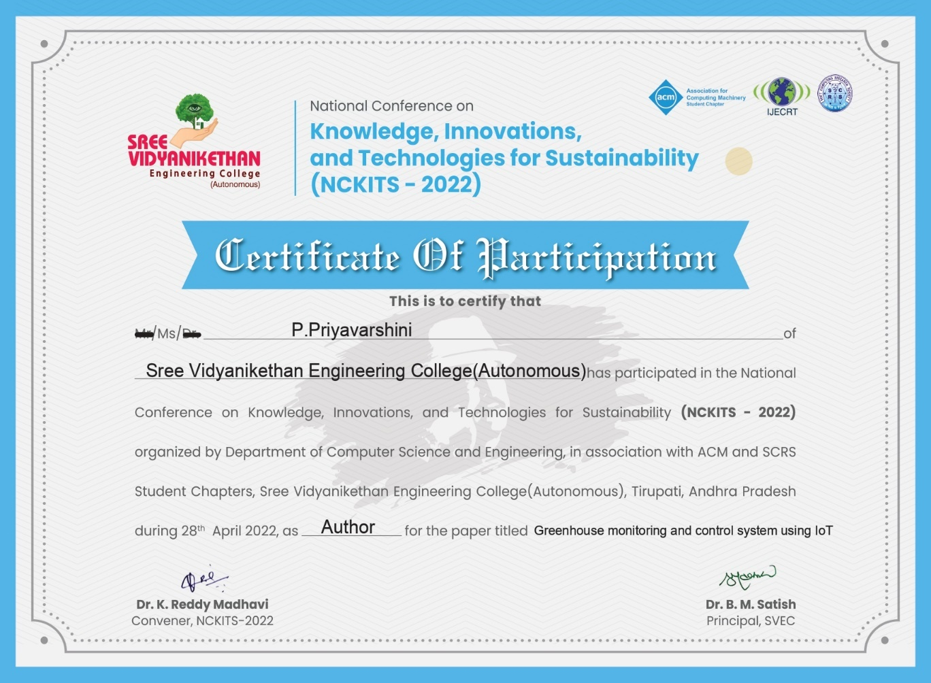

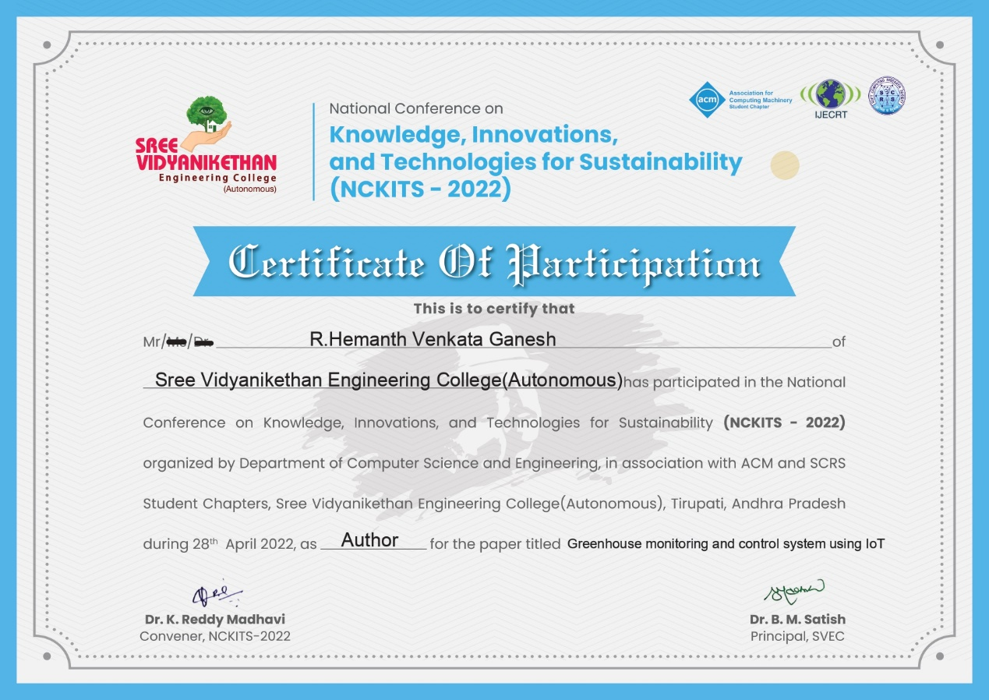

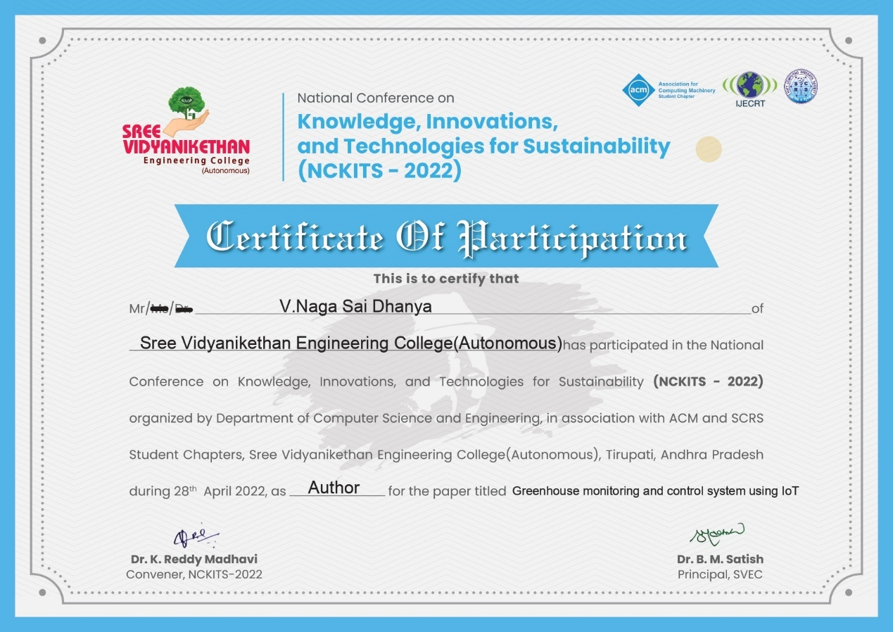

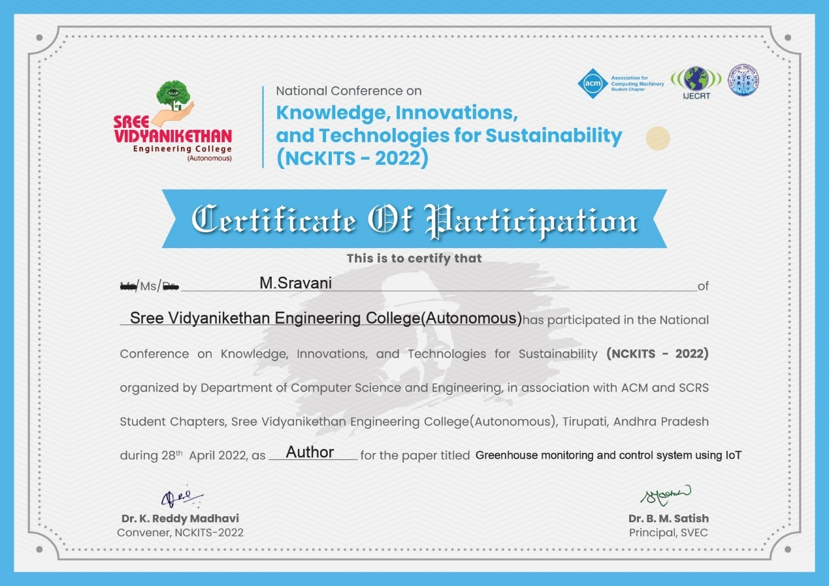

**REFERENCES**

1. Floreano D, Wood RJ (2015) Science, technology and the future of small autonomous drones. Nature 521:460–466.
2. Li F, Mistele B, Hu Y, Chen X, Schmidhalter U (2014) Reflectance estimation of canopy nitrogen content in winter wheat using optimised hyperspectral spectral indices and partial least squares regression. Euro J Agron 52:198–209.
3. 3.Bareth G, Aasen H, Bendig J, Soukkamäki J (2015) Low-weight and UAV-based hyperspectral full-frame cameras for monitoring crops: Spectral comparison with portable spectroradiometer measurements. Photogrammetrie, Fernerkundung, Geoinformation 2015:69–79.
4. 4.Wahabzada M, et al. (2016) Plant phenotyping using probabilistic topic models: Uncovering the hyperspectral language of plants. Sci Rep 6:22482.
5. Umstatter C (2011) The evolution of virtual fences: A review. Comput Electron Agric 75:10–22.
6. Schulze ED, et al. (2009) Importance of methane and nitrous oxide for Europe’s terrestrial greenhouse-gas balance. Nat Geosci 2:842–850.
7. Dalhaus T, Finger R (2016) Can gridded precipitation data and phenological observations reduce basis risk of weather index-based insurance? Weather Clim Soc 8:409–419.
8. 8.Poppe KJ, Wolfert S, Verdouw C, Verwaart T (2013) Information and communication technology as a driver for change in agri-food chains. EuroChoices 12:60–65.
9. DeFries R, et al. (2015) Global nutrition. Metrics for land-scarce agriculture. Science 349:238–240.
10. Charo RA (2015) SCIENCE AND GOVERNMENT. Yellow lights for emerging technologies. Science 349:384–385.
11. Iozzio C (2016) Who’s responsible when a car controls the wheel? Scientific American 314:12–13.
12. Kutter T, Tiemann S, Siebert R, Fountas S (2011) The role of communication and co-operation in the adoption of precision farming. Precis Agric 12:2–17.
13. Baumgart-Getz A, Prokopy LS, Floress K (2012) Why farmers adopt best management practice in the United States: A meta-analysis of the adoption literature. J Environ Manage 96:17–25.
14. Tilman D, Cassman KG, Matson PA, Naylor R, Polasky S (2002) Agricultural sustainability and intensive production practices. Nature 418:671–677.
15. Sachs JD (2015) The Age of Sustainable Development (Columbia Univ Press, New York).

16.Aditya Vishwakarma,Ankit Sahu,Nadeem sheikh, “IOT based greenhouse monitoring and controlling system”,2020 IEEE Students Conference on Engineering & Systems (SCES) July 10-12, 2020 Prayagraj, India”.

17.Tripura Pidikitia, Kishore Yadlapatib, Fredric Samson Kirubakaran Sakthirajc, “Wireless Green House Monitoring System Using Raspberry PI”, Turkish Journal of Computer and Mathematics Education, Vol.12 No.2(2021) 2163–2169”, Published online: 5 April 2021.

18.Jiabul Hoque,Saif hannan,Md Razu Ahmed, “An Automated Greenhouse monitoring and controlling system using sensors and solar power”, Article in European journal of engineering Research and Science-April 2020.

19.Dewi Kania Widyawati,Agus Ambarwari, Anung Wahyudi, “Design and Prototype Development of Internet of Things for Greenhouse Monitoring System”, 2020 3rd Internationl seminar on Research of Information Technology and Inteligent systems(ISRITI).

20.V. Vineela, P. Bhavya, B.Sandeep,”Agricultural crop monitoring and controlling using IOT”,2019 International Journal of Engineering and Advanced Technology(IJEAT).

**SREE VIDYANIKETHAN ENGINEERINGCOLLEGE (AUTONOMOUS)**

## Sree Sainath Nagar, A. Rangampet - 517 102

## Department of Electronics & Communication Engineering

**Project Title: Green House Monitoring and Control System Using IOT**

**ABSTRACT**

This work demonstrates the design and implementation of a various sensors for greenhouse environment monitoring and controlling with various techniques using Node MCU ESP8266 module. This greenhouse monitors and control system consists of temperature sensor, Air quality sensor, soil moisture sensor, LDR sensor, LCD display module, 12v DC fan, electric Bulb water pump motor, servo motor with IoT technology. The Temperature sensor, senses the level of temperature, if it goes high DC fan gets on and when the temperature goes low the fan gets off.Soil moisturesensor, senses the water level as the level decreases the pumps gets on. In the absence of light, the LDR sensor senses and the bulb starts glowing. Air quality sensorsenses the levels of carbon dioxide (CO2) present within the greenhouse and alerts the Arduino if the level of co2 decreases. By this way it will become easy to monitor and control the system. With the help of HTTP protocol, the Node MCU module is connected to the wireless internet connection or through IoT platforms like ubidots.com. The collected environmental parameters data sent to smartphones via online mode to the farmers to make the proper overlook on their fields, no matter how far they are just by using the IoT platform. In the field of agriculture and food production, the technology has paced up very quickly and is still furnishing its way, to optimize and achieve maximum plant growth in the field of agriculture. An accurate system would surely bring the change in this world of Android/IDS smartphone applications.

**Keywords**: Greenhouse, Temperature sensor, Soil moisture sensor, LDR sensor, Air Quality sensor, Arduino UNO, ESP266 Wi-fi module, Ubidots.com IoT platform

**PROJECT BATCH: 22B16**

P.Priyavarshini -18121A04G9

R.Hemanth Venkata ganesh -18121A04J2

Naga sai Dhanya.V -18121A04D8

M.Sravani-18121A04D5

**GUIDE:** Dr. M. DHARANI, M.Tech., Ph.D., Associate Professor, Dept. of ECE

|  |  |  |  |  |  |  |  |  |  |  |  |  |  |  |  |  |  |  |
| --- | --- | --- | --- | --- | --- | --- | --- | --- | --- | --- | --- | --- | --- | --- | --- | --- | --- | --- |
|  | **Program Outcomes** | | | | | | | | | | | | | **Program Specific** Outcomes | | | | |
| **PO1** | **PO2** | **PO3** | **PO4** | **PO5** | **PO6** | **PO7** | **PO8** | **PO9** | **PO10** | **PO11** | **PO12** | **PSO1** | | **PSO2** | **PSO3** | **PSO4** |
| GreenHouse  Monitoring and Control System Using IOT | **√** | **√** | **√** | **√** | **√** | **√** | **√** | **√** | **√** | **√** | **√** | **√** | **√** | | **√** | **√** | **√** |

**BIO-DATA**

|  |  |  |
| --- | --- | --- |
| Name | : | Poola Priyavarshini |
| Father’s Name | **:** | P.Venkateswarlu |
| Date of Birth | **:** | 27 June 2001 |
| Nationality | **:** | Indian |
| Contact Number | **:** | 9381330467 |
| E-mail id | **:** | Priyavarshinipoola123@gmail.com |
| Address | **:** | 13-46/14B, jandamanu street extension, puttur, Chittoor,517583 |

**BIO-DATA**

|  |  |  |
| --- | --- | --- |
| Name | : | Ravva Hemanth Venkata ganesh |
| Father’s Name | **:** | R.Rangaiah |
| Date of Birth | **:** | 10 Jan 2001 |
| Nationality | **:** | Indian |
| Contact Number | **:** | 9347576559 |
| E-mail id | **:** | Hemanth3860@gmail.com |
| Address | **:** | 19-9-29/14E,Lakshmipuram ,Tirupathi,chittor,517501 |

**BIO-DATA**

|  |  |  |
| --- | --- | --- |
| Name | : | Mummineni Sravani |
| Father’s Name | **:** | M.sahadeva |
| Date of Birth | **:** | 15 July 2001 |
| Nationality | **:** | Indian |
| Contact Number | **:** | 8096110827 |
| E-mail id | **:** | Sravani3218@gmail.com |
| Address | **:** | 7/8, yeguvarajuvaripalli,devaptla,Sambepalli,  Annamayya district,516215 |

**BIO-DATA**

|  |  |  |
| --- | --- | --- |
| Name | : | Naga Sai Dhanya.V |
| Father’s Name | **:** | V.Pavan Kumar |
| Date of Birth | **:** | 5th April 2001 |
| Nationality | **:** | Indian |
| Contact Number | **:** | 9515412922 |
| E-mail id | **:** | dhanyaveerepalli@gmail.com |
| Address | **:** | Flat 409, Venkata padmavathi enclave, KR nagar, Tannapalli cross, Tirupati, Balaji dist, 517503. |